**Introduction**

**Spring cloud component**

1. **Eureka naming service**

Eureka allow our m/s to register themselves with the naming server and the other m/s can use the naming server to fetch the details of m/s they want to communicate and easily communicate with them

So it is all about registration and discovery of m/s

1. **Feign Client**

It makes super easy to create restful client . Instead of using restTemplate will use FeignClient

We will simply create interface and also can use annotation like @RequestMapping and more which we earlier use on server side

1. **Load Balancing - Ribbon**

client side load balancing using ribbon component . Ribbon allow us to spread our request across different instance of same m/s running on the server

**4- Fault Tolerance**

When m/s is down all it clients should not throw exception , will learn how hystrix component handle exception gracefully

1. **Zuul Proxy**

Help server side load balancing :--- all the m/s request can go through zuul proxy where we can addressed

Cross cutting concern ,security. Anything we want across the m/s can put in zuul proxy.

1. **Sleuth and Zipkin**

when lot m/s is running with in organization we have to be very careful when we are tracing

where is the request coming and from where it is going to so **sleuth** is the component which

Help in distributed . If we configure sleuth able to know from where the m/s is originated and from

Which m/s it is going to which other m/s and all can be easily traced using trace id that sleuth generates

And **zipkin** which will takes all log and show in centralized dashobard like ui

The Basics

Note :--

We can create as many M/S as we want but there are some **non functional requirement**

**1-Service registration and discovery :-- is provided by netflix eureka**

Each m/s have to register itself within centralized server and the other m/s will be able to discover

That particular m/s and communicate with it dynamically without that each m/s is tightly coupled with other m/s

1. **Load balancing----------is provided by ribbon**

As the load to m/s increase will have to multiple instances of same m/s running on diff server

And the load should be balanced

1. **Fault Tolerance-----------is provided by hystrix**

if something goes down in one of the m/s then entire system should not goes down

So these m/s should be fault tolerant and handle fault gracefully

1. **Easy Communication or integration :--------feign client**

they should be able to communicate with each other easily through restful client api in easy step

1. **Cross cutting concerns------------are configured using zuul proxy gateway**

which are common across m/s like security, authorization ,logging etc

**6- Distributed Tracing-------sleuth and zipkin and zipkin will give nice dashboard**

as the request goes from one m/s to another m/s we should able to trace how the request is going and how

Response is coming back and something goes wrong we should able to know where the thing goes wrong

**Imp:---**

so all these are not available in spring boot that is **where spring cloud comes in.**

**Spring cloud** is the collection of open source component that help us implement all these and more

**Ports :-**

|  |  |
| --- | --- |
| **m/s component** | **port used** |
| Coupon service | 8080 and 8081 // two instance will run |
| Product Service | 9090 |
| Eureka server | 8761 |
| Zuul api gateway server | 8765 |
| Config server(spring cloud config) | 8888 |
| Zipkin distributed tracing server | 9411 |

**Usecase**

Product m/s

Coupon m/s

These two m/s will expose restful api which will allow client to create a product and in the process

Product service will use a coupon service to apply a coupon code that client passes in and

Get the discount so all the coupon information is maintained by coupon service and product service is only responsible for creating the product in the d/b along with price and description details which the client passes.

**The process here ;-**

is take client request , the production service will call the coupon service get the discount for coupon code which the client would have passed apply the discount on the price which the client passes

And then save the product to the d/b. all the coupon info will save in coupon service d/b

**Client ------------product service (ms1)------------couponcode -------------coupon service (ms 2)**

**Create Coupon m/s**

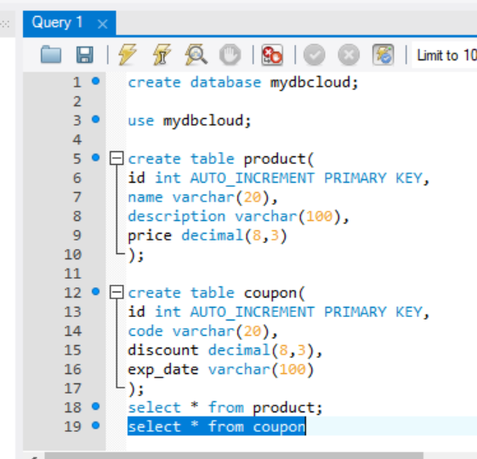

**Steps**

Create the project

Create model and repository

Create the rest controller

Configure the data source

Test

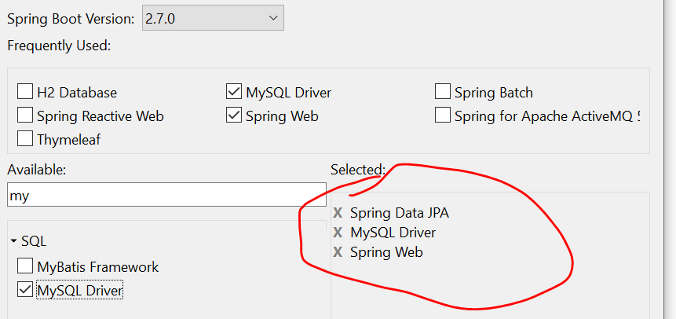

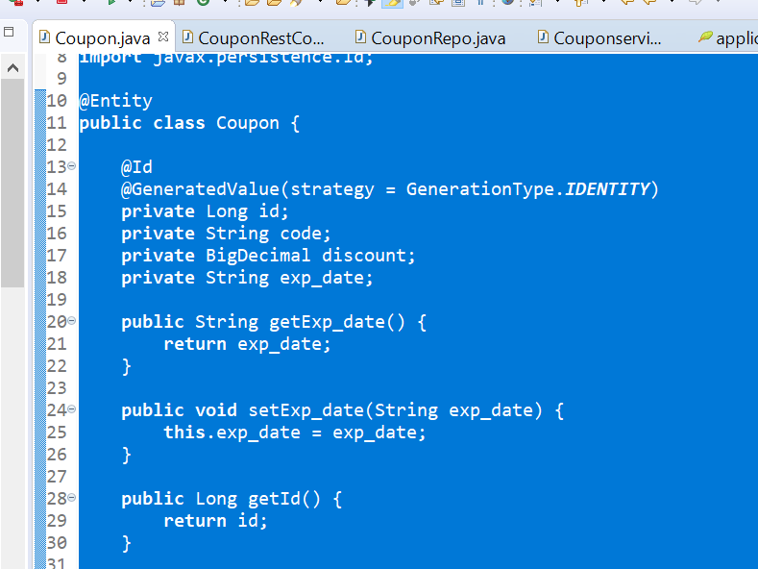

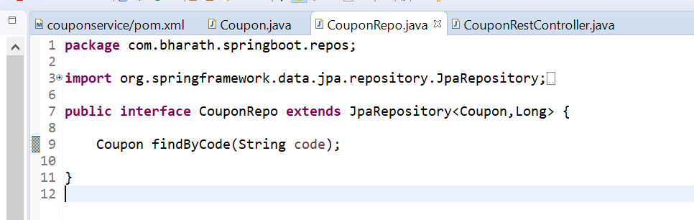

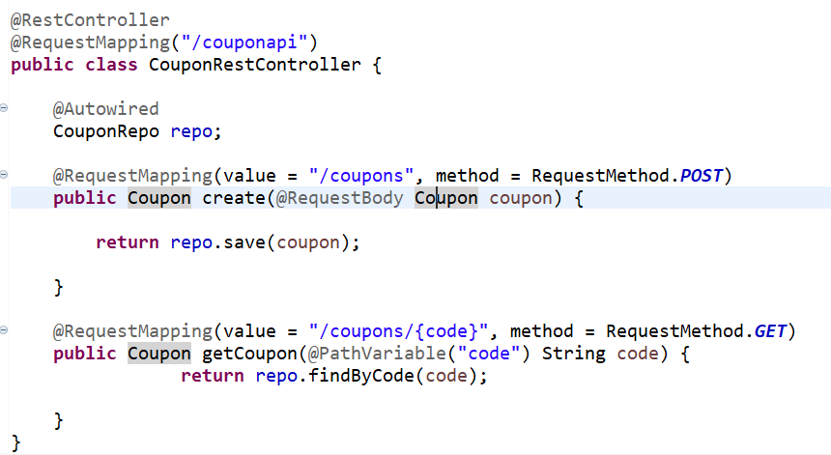

Configure the data source

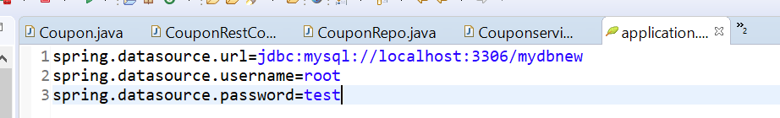

Execute :

Create a coupon using postman

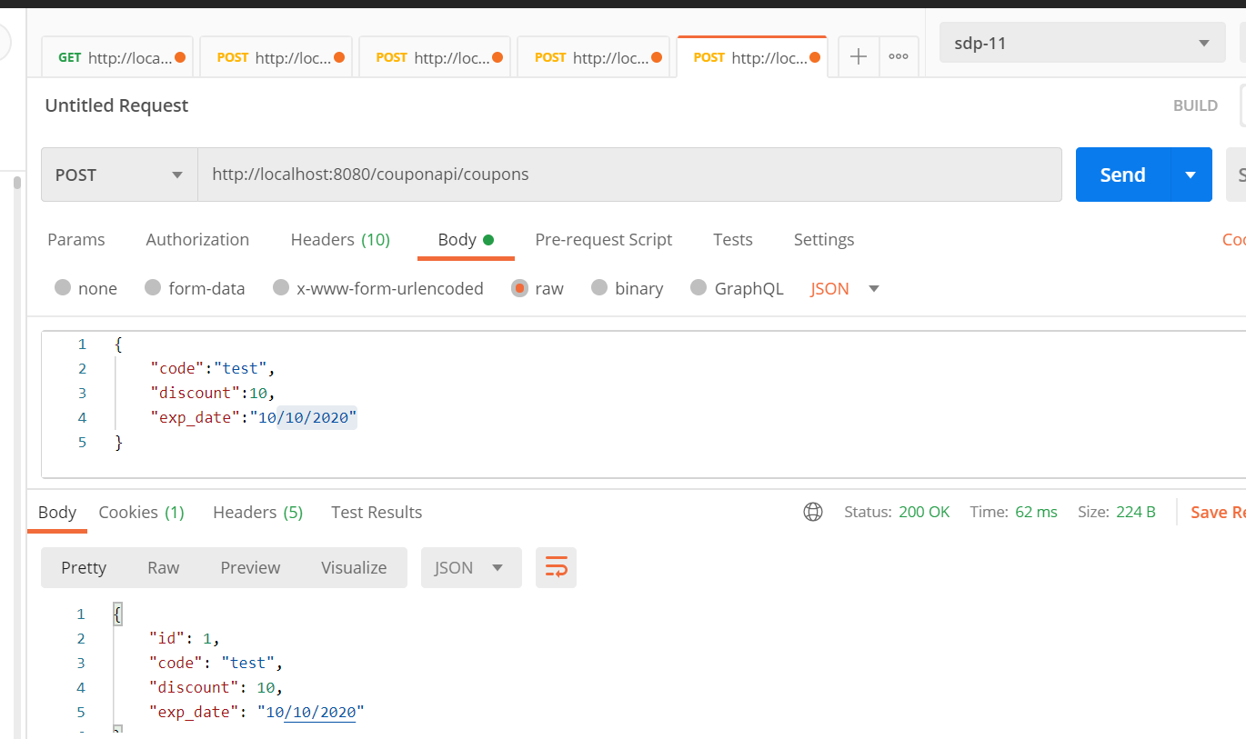

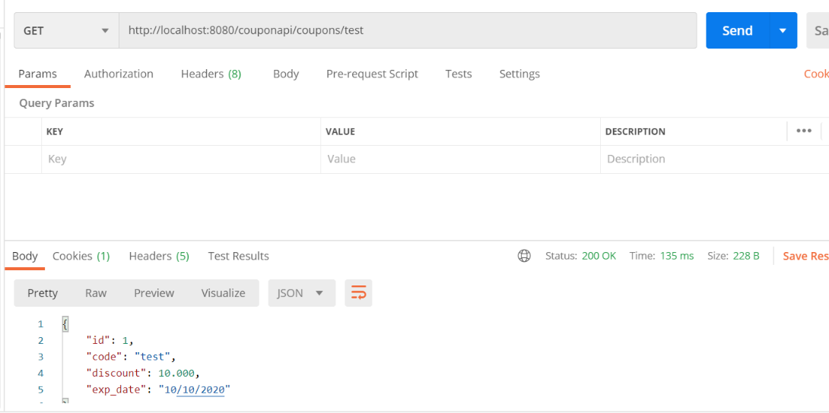

Create Product Microservice

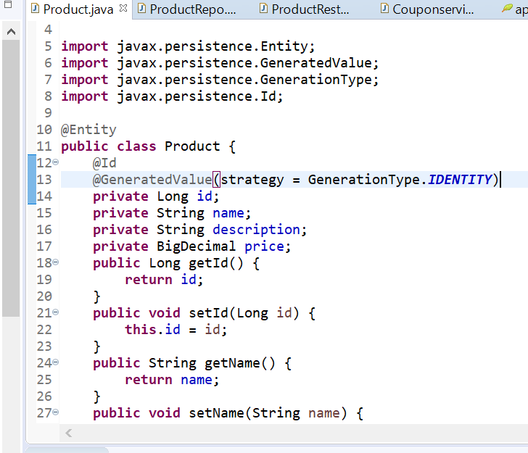

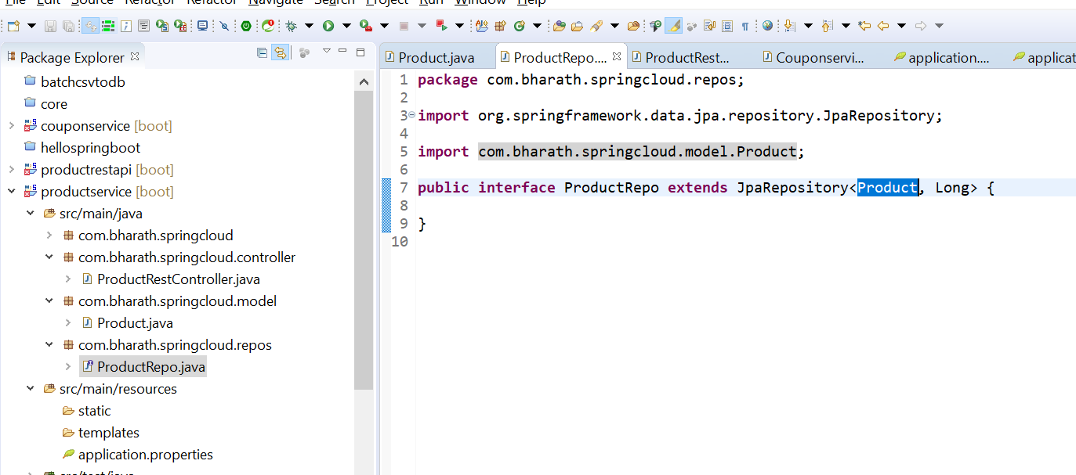

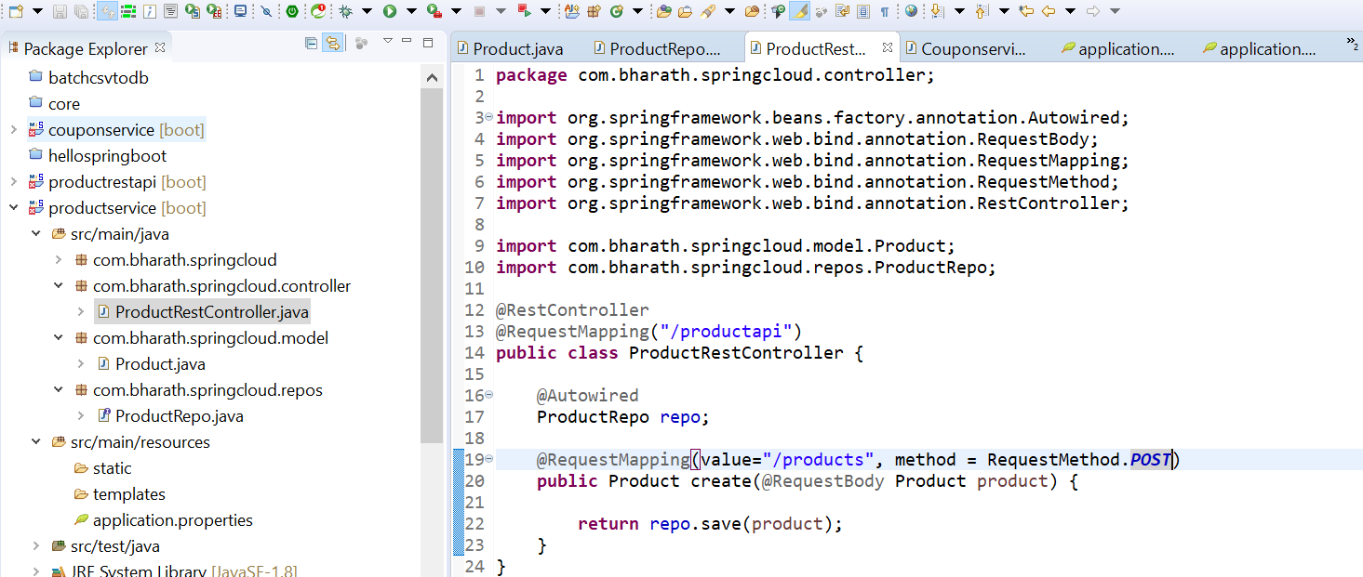

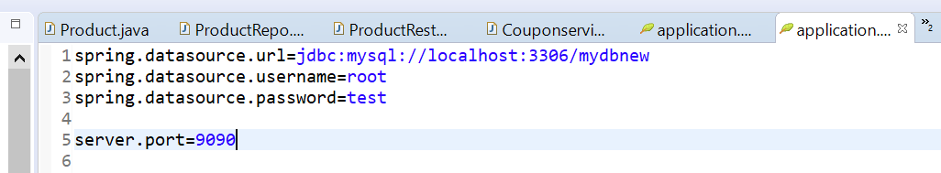

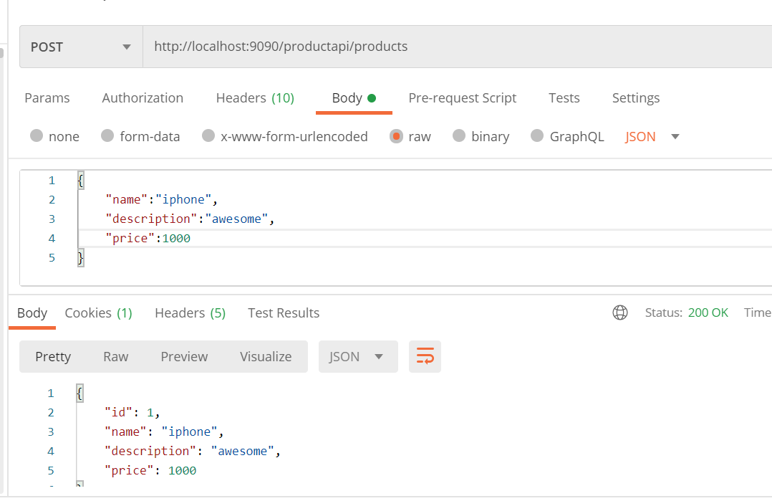

Service Discovery Using Eureka

1-There may be different instance of same m/s running and when other m/s want to communicate then they

Required url or port number to communicate this is very hard to maintain that is why spring cloud offer

Naming services or name server called **eureka**

2-So when m/s comes up they register themselves in name server through application name or application id

Which is unique id for each application and also url will be fetch by name server to communicate with m/s.

Once all the info of m/s store in eureka server the service consumer when they come up can communicate

With the naming server fetch those details just the application name. as long as consumer know the application id they can fetch url and port no

In our case product service will fetch details from eureka server about coupon service through application name and communicate and coupon service will register in eureka server

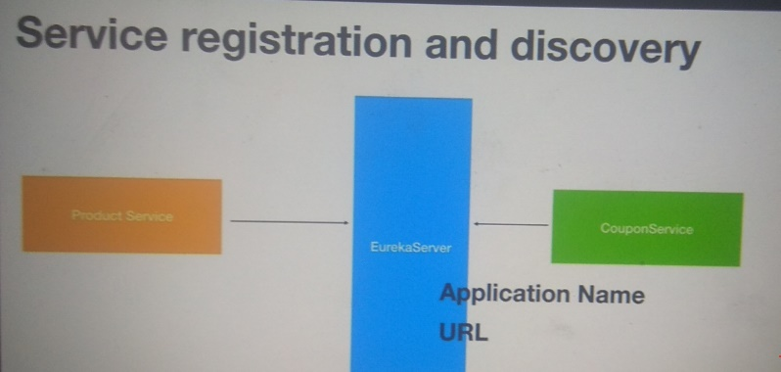

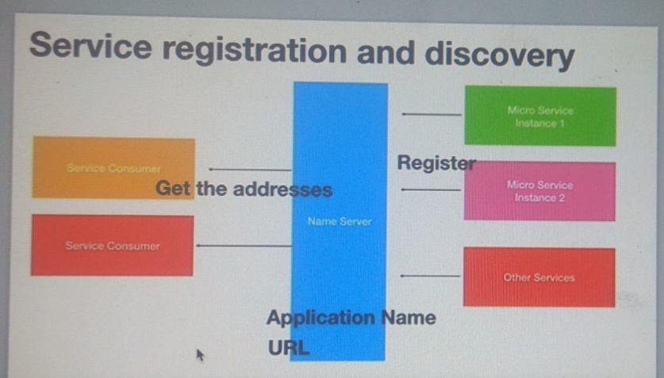

**Step**

Create the project

Add eureka server dependency

Enable eureka server

Configure the properties

Test

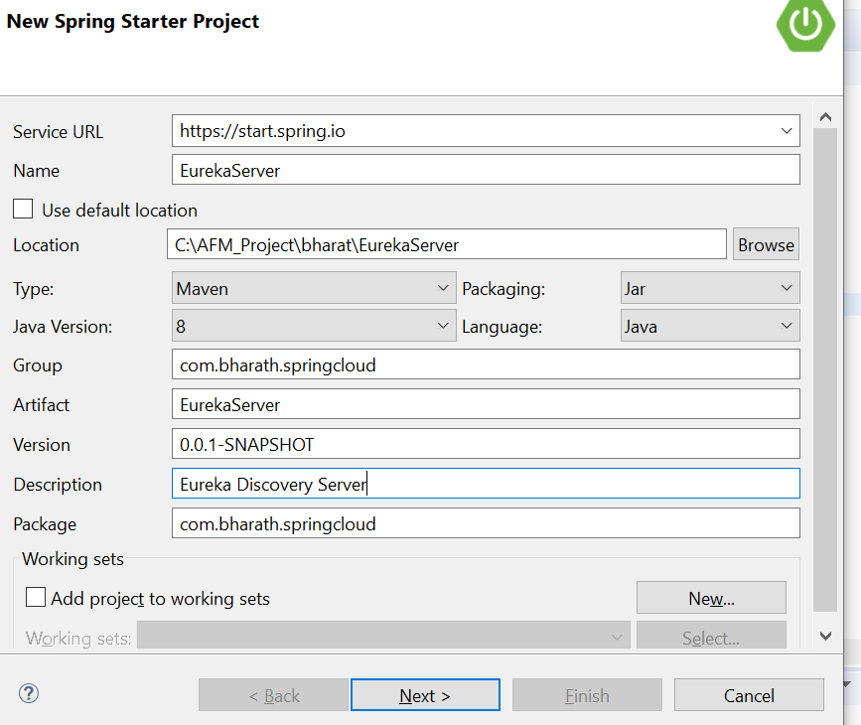

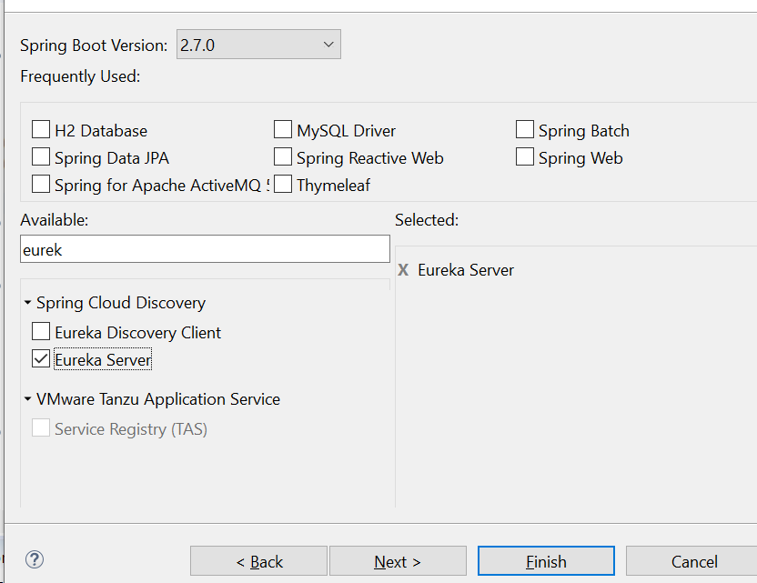

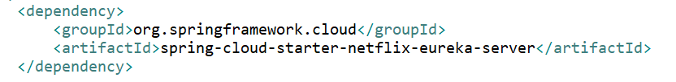

**Enable server and configure properties**

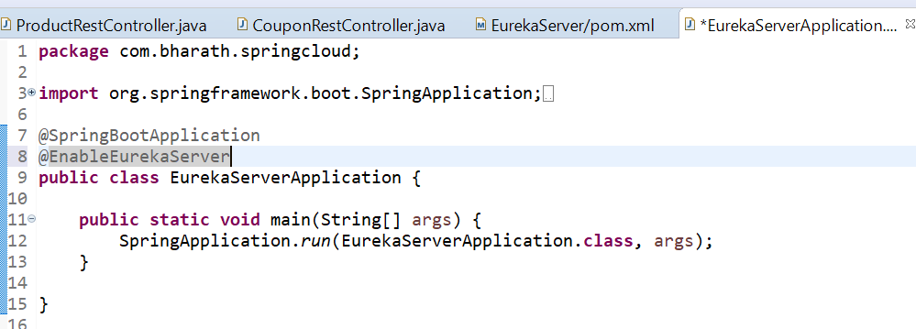

**Note :--**

eureka server application should not register with eureka server that’s why explicitly we need to define

In eureka properties file

By default below value is true that’s why we need to define in eureka server

**eureka.client.register-with-eureka=false**

Eureka server does not require to have registry because it have registry and other m/s this value is true

Because they need to fetch the registry to know url where other m/s are running

**eureka.client.fetch-registry=false**

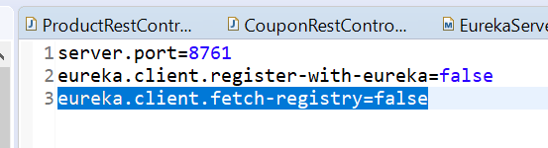

**Eureka server in action**

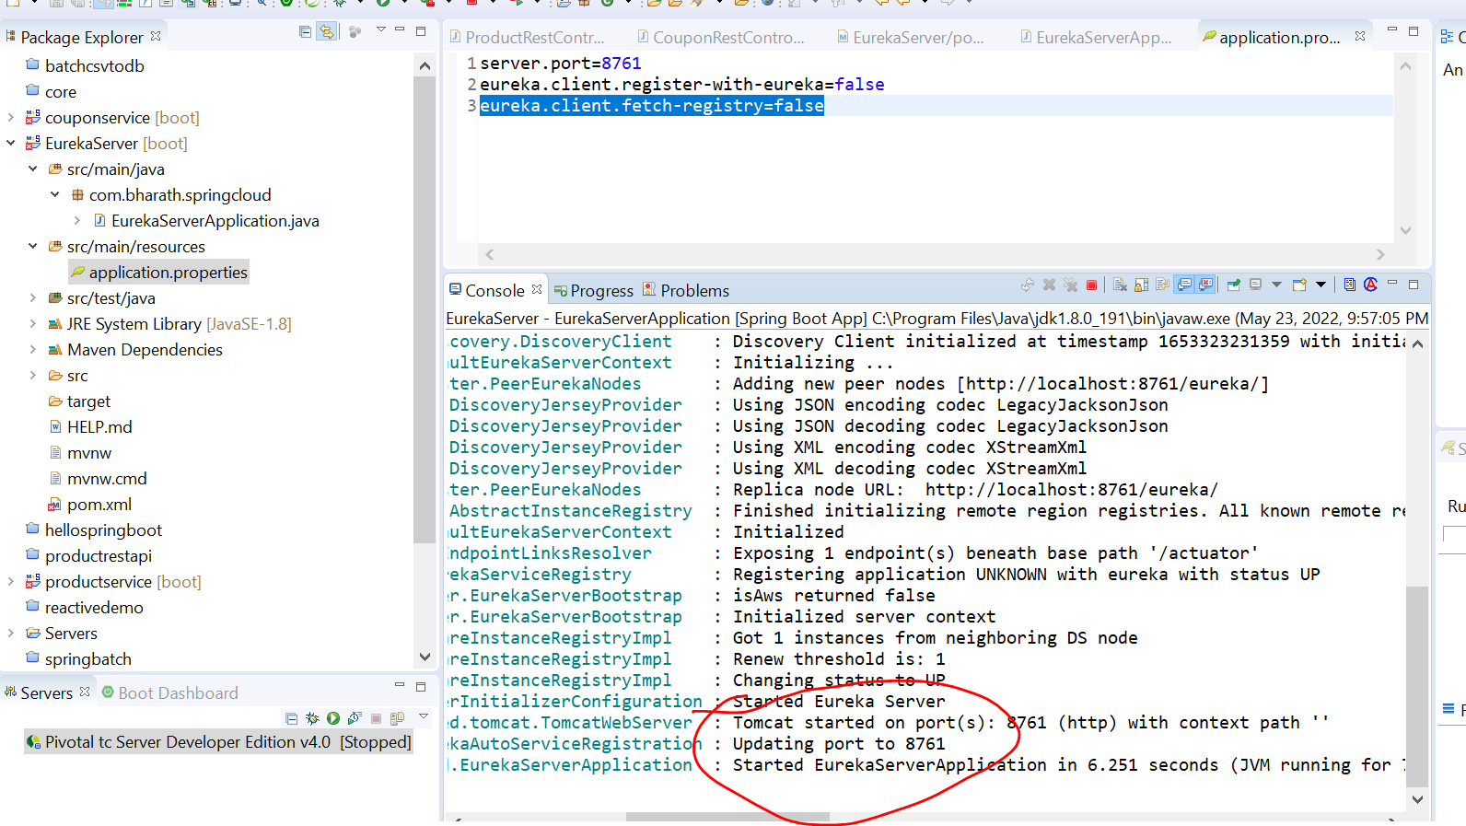

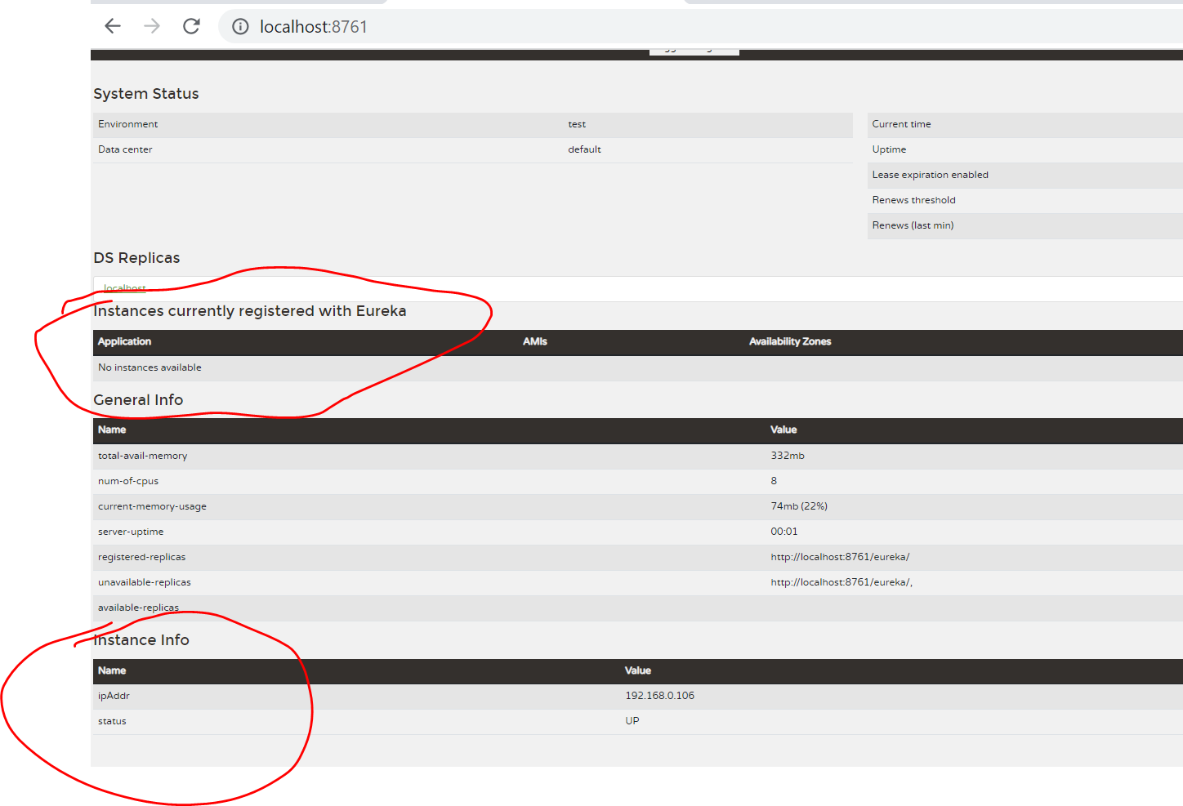

**Instance info :---**eureka server info

Currently no instance or m/s registered with eureka

**Add eureka discovery client dependencies**

**Registering m/s with eureka server**

**Steps:-**

Version :- 2021.0.2

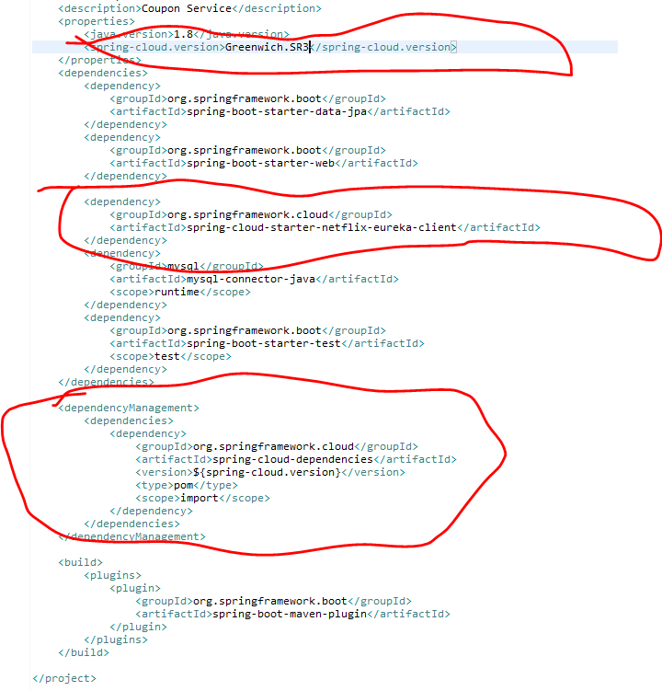

Dependency management will pull all cloud related dependencies

**Enable and configure the client**

**Register coupon service and product service with eureka server**

**@EnableEurekaClient**

That will make m/s application a client to eureka server

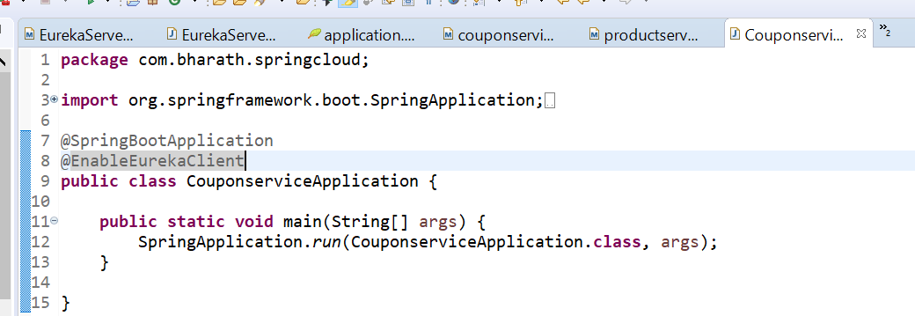

**This is the name through which client register in eureka server**

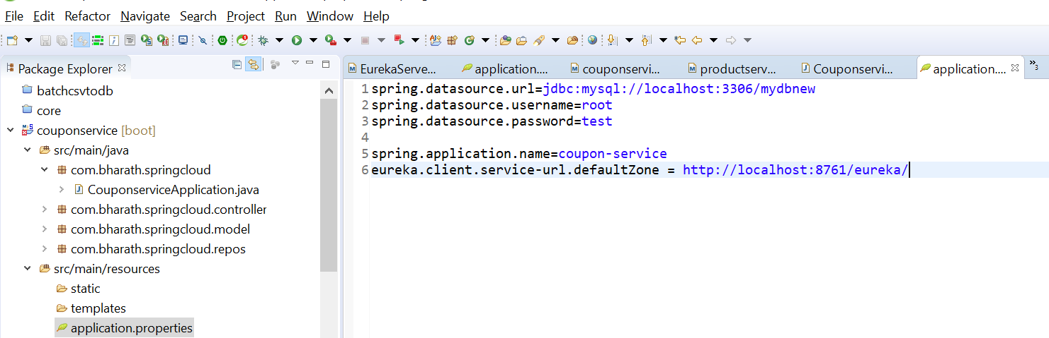

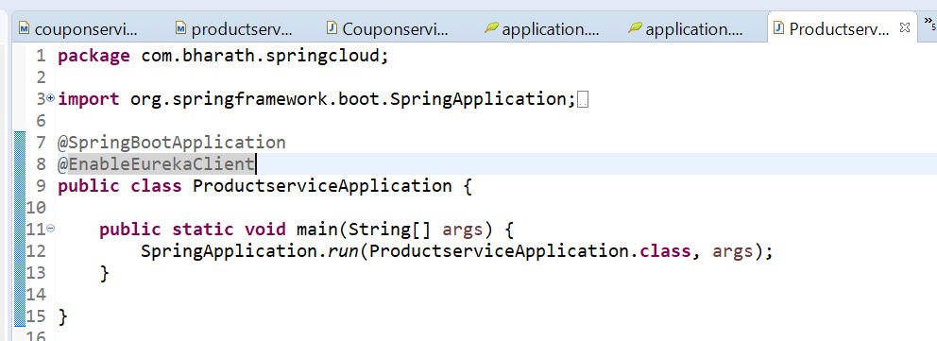

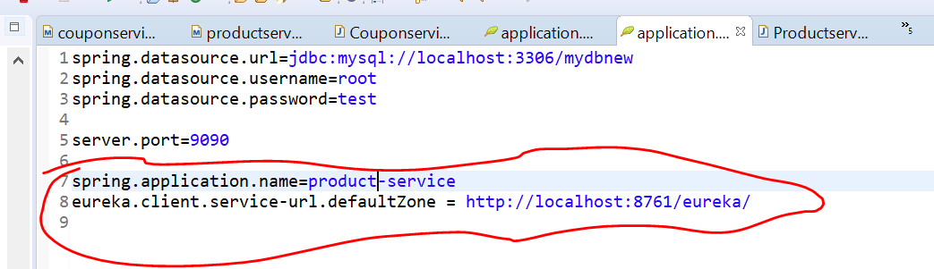

**Run and Test**

Start all three server and see it register in eureka server or not

**Note**

**No instance registered when we start only eureka server**

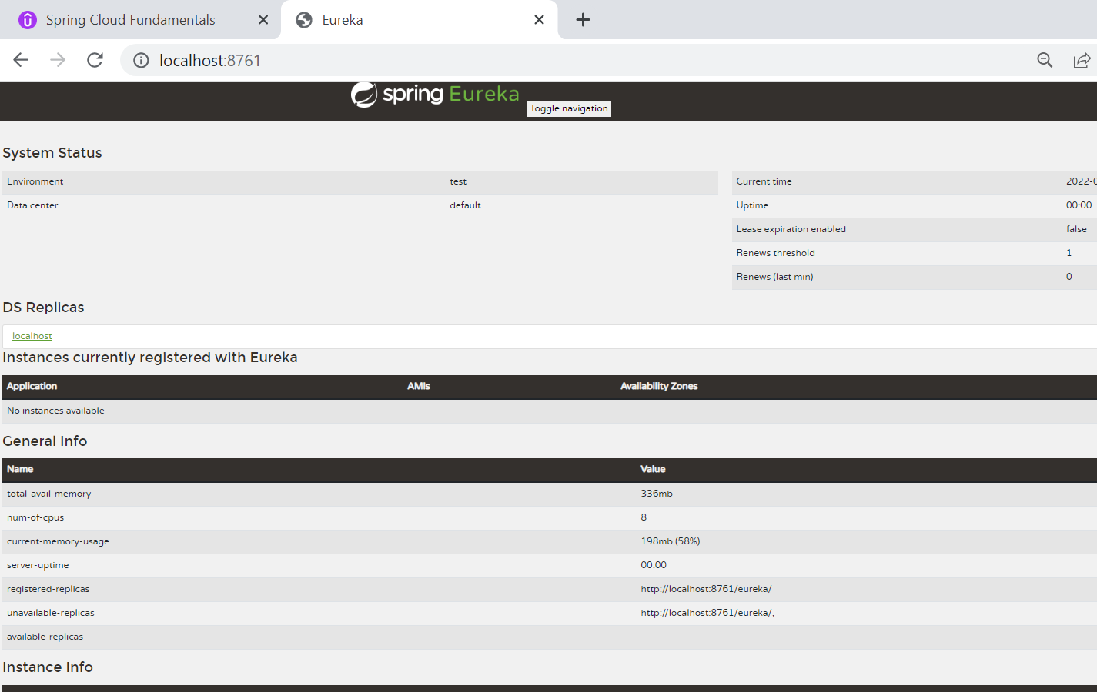

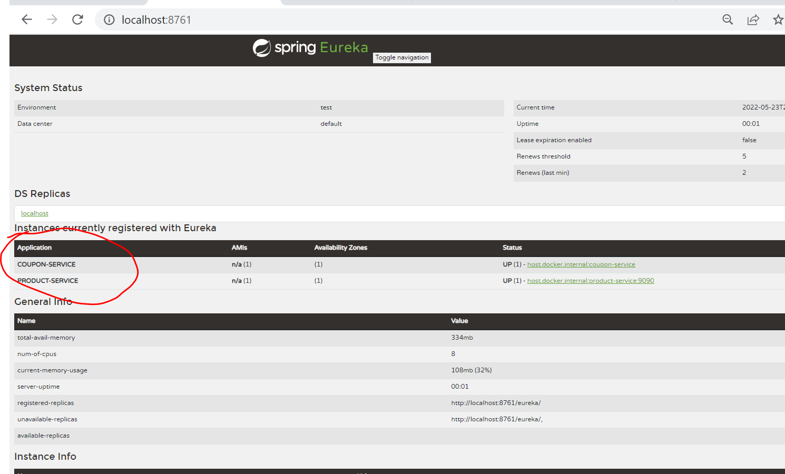

**Note**

Now other m/s can discover m/s through eureka server

Rest Client Using Feign

Note

ProductService will become a restful client to couponService

Since productService to call couponService and get a discount so that it can be applied

**RestTemplate** is there to make restful call but it has to do lot of coding

On other hand spring-cloud offers FeignClient. Using this we can declarative create restful client

And it is very easy and it integrate with eureka

**Integrate productService with couponService through feign client**

**Steps:**

Add the feign client dependency

Create the rest client

Use the rest client

Enable feign client and tests

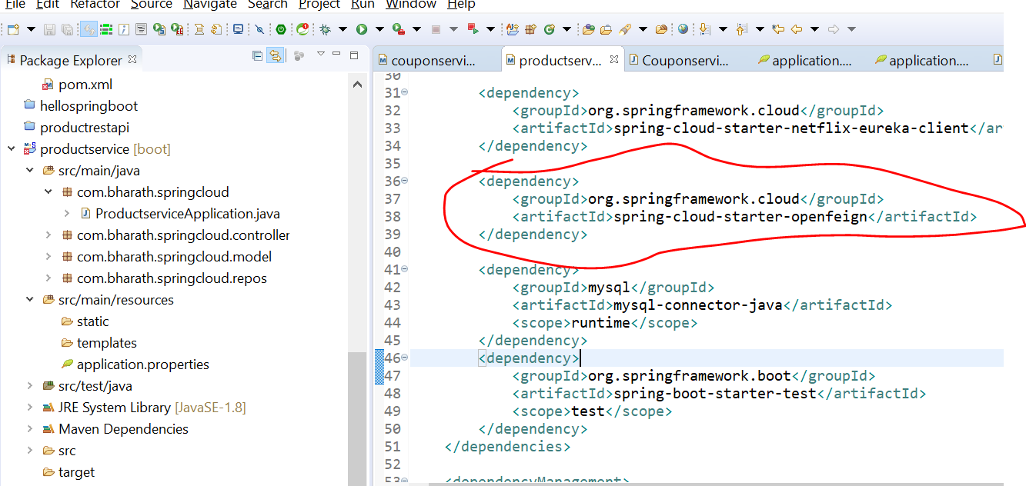

**Working one**

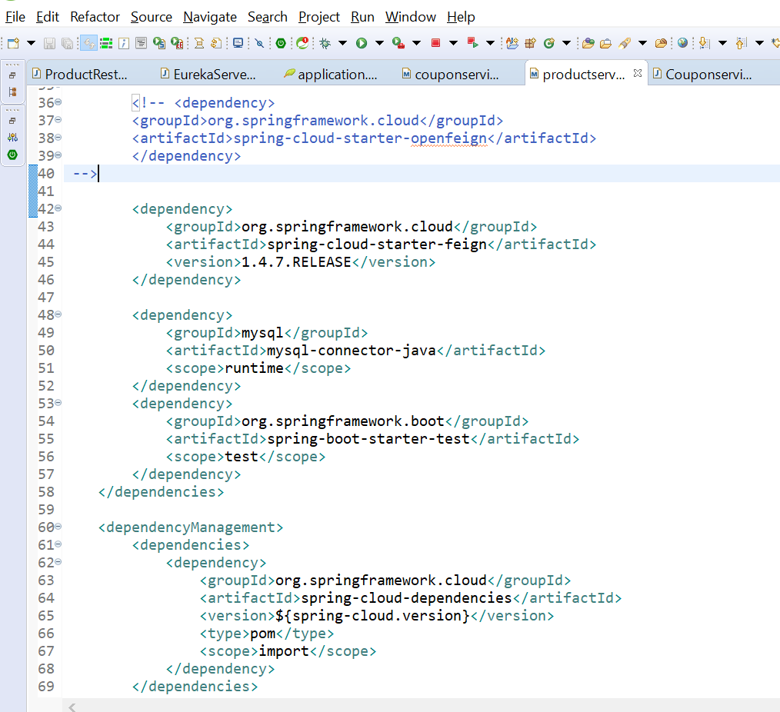

**Create the feign rest client**

**Step2 :-**

Add coupon model and paste it in ProductService model and remove all jpa dependency

Note :--

Just like we use annotation in server side we need to use with feignClient also

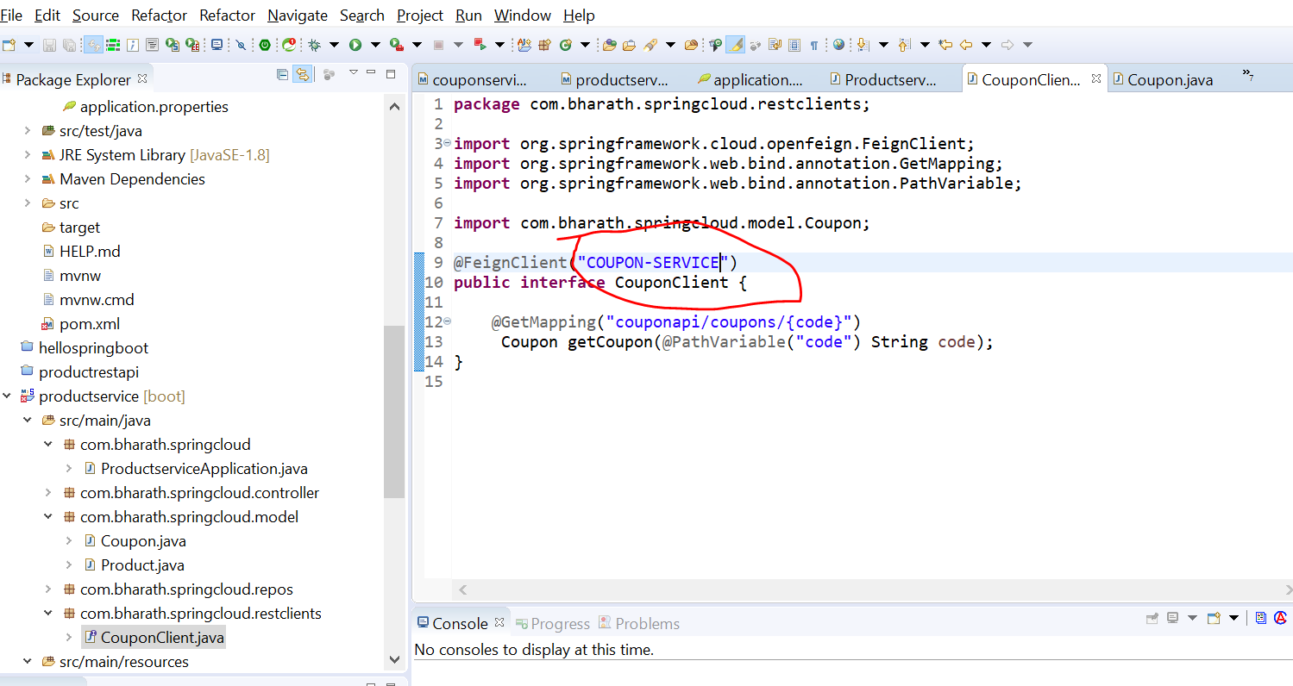

**Note**

When this method will call from productService it will send code and binding it is reversed from code

It will mapped to url code and invoked m/s and get Coupon back

Automatically it will discover Coupon-service that is register in eureka server

**Use the Client**

**Use the Rest feignClient that we have created inside the productRestController and applied discount**

**Note :**

couponCode will not save in d/b so we need to marked with @Transient so that orm tool will

Ignore it , when required to save in d/b

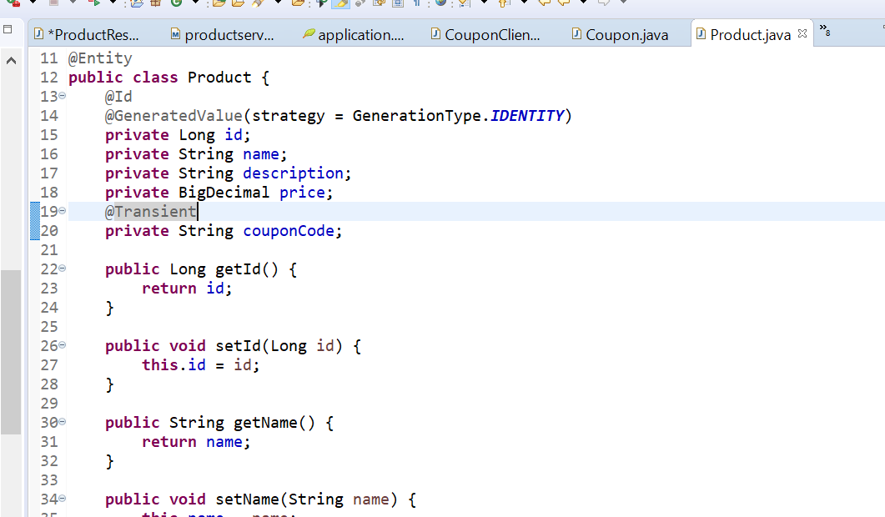

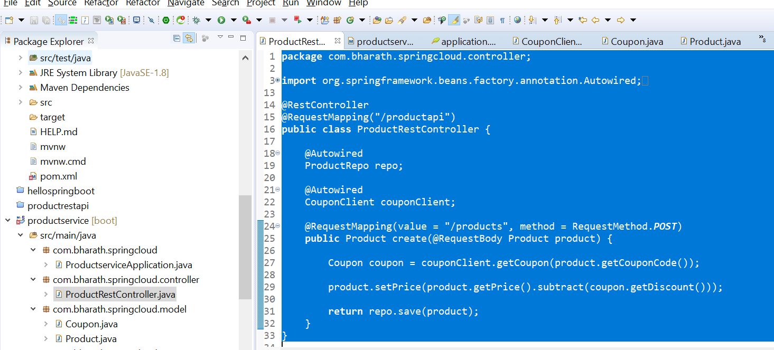

**Enable Feign Support and test**

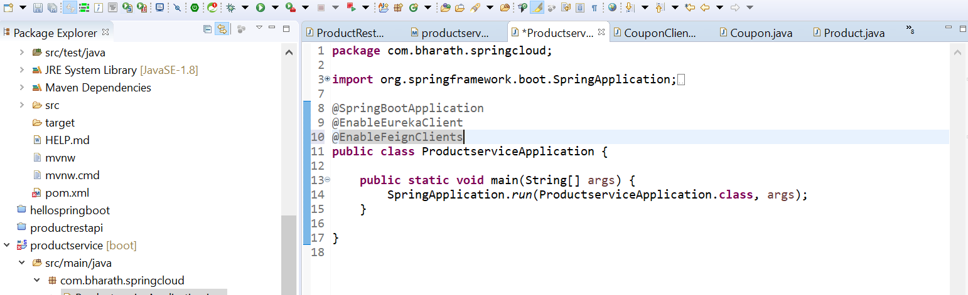

**Client Side Load balancing**

Multiple instance of couponService will create and need to load balanced from client side(ProductService)

**Configure and Test**

**Load balancing support to productService which will make call to couponService**

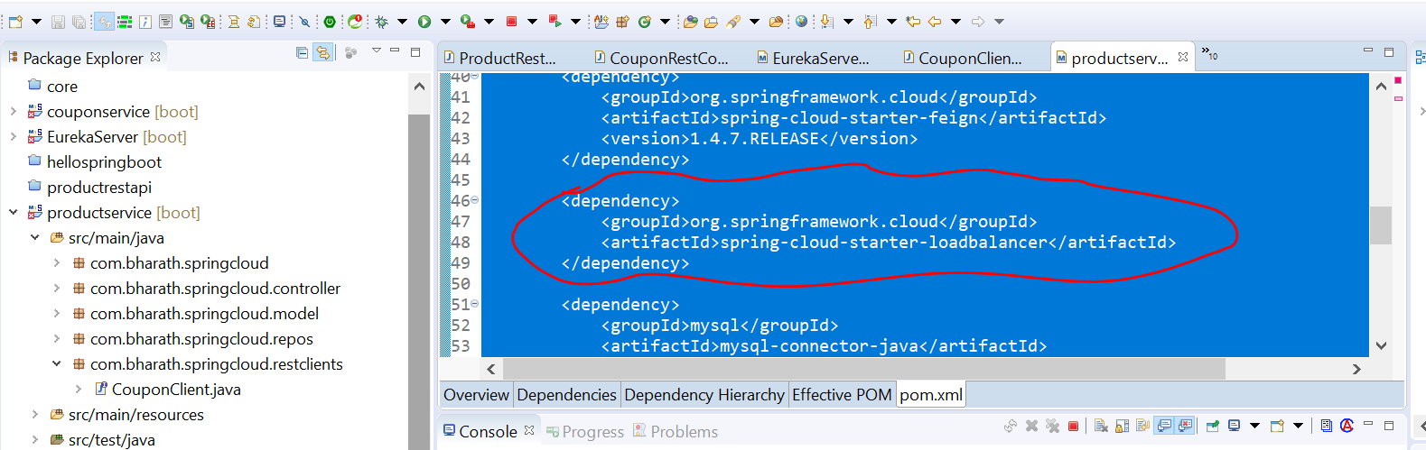

**After adding this in ProductService automatically load will be balanced if we have running multiple instances**

**Of CouponService**

**Note**

We have two instance of couponService is running

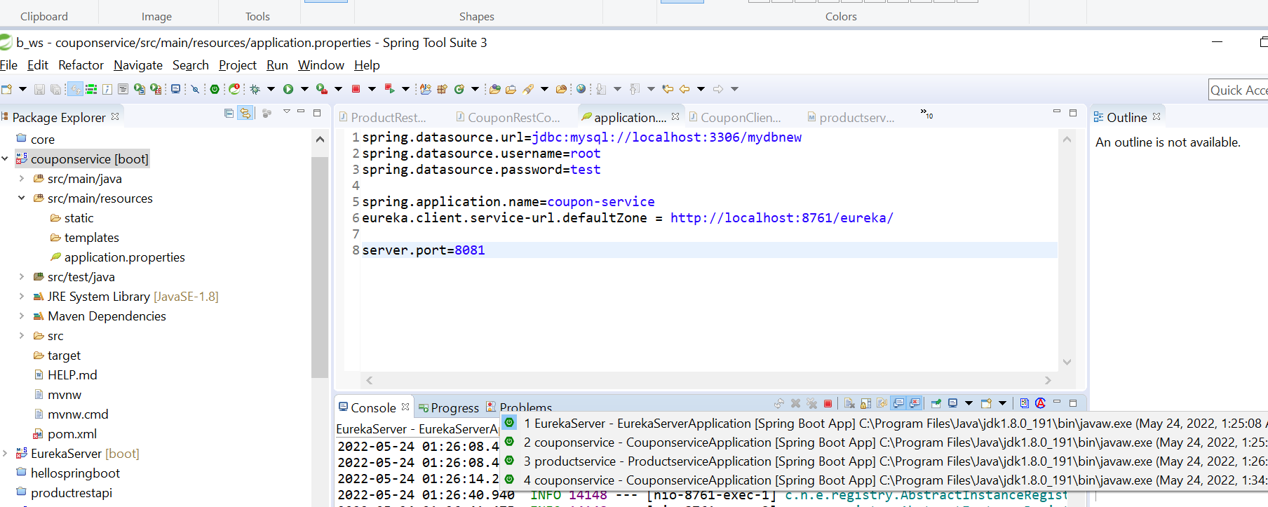

In case of running in two different machines we are using two different port

Now multiple instances of couponservice we can see in url

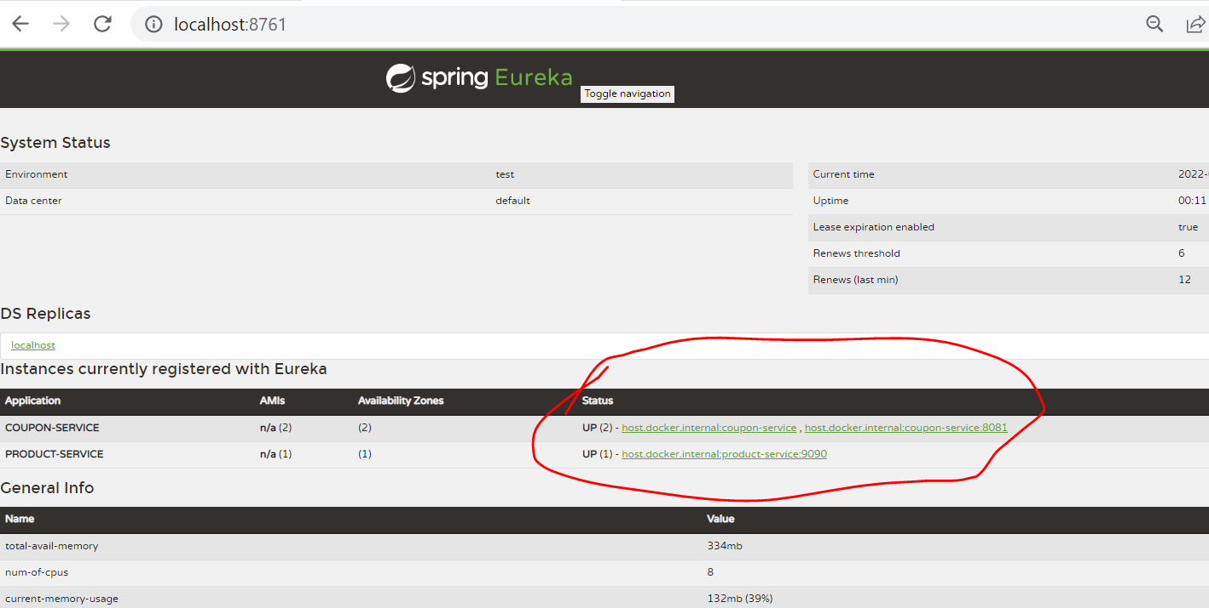

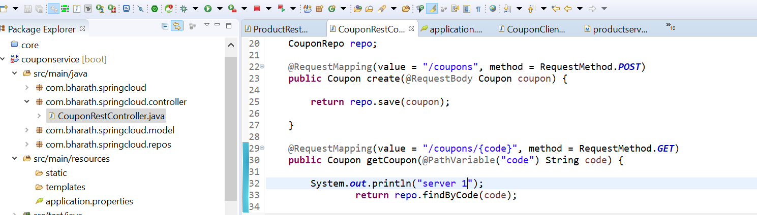

This will run at 8080 and server 1

After running configure the port in coupon service

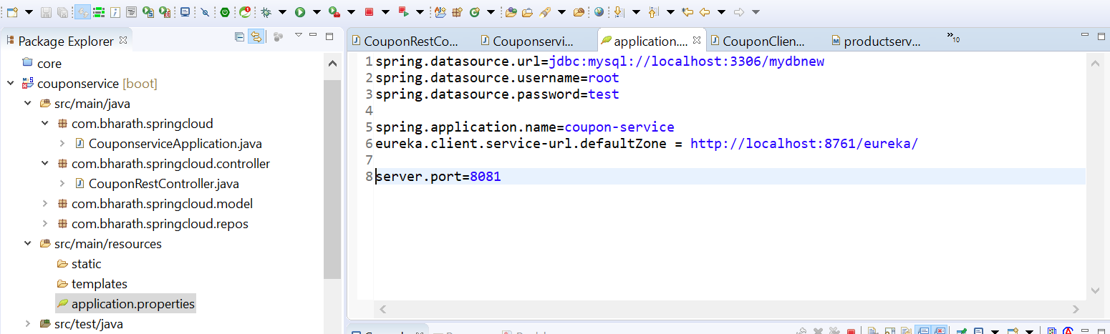

This will run at 8081 and server 2

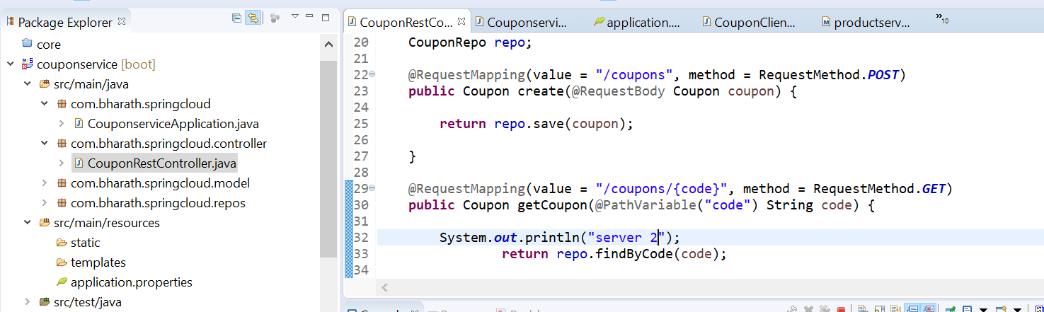

Now when will hit using postman

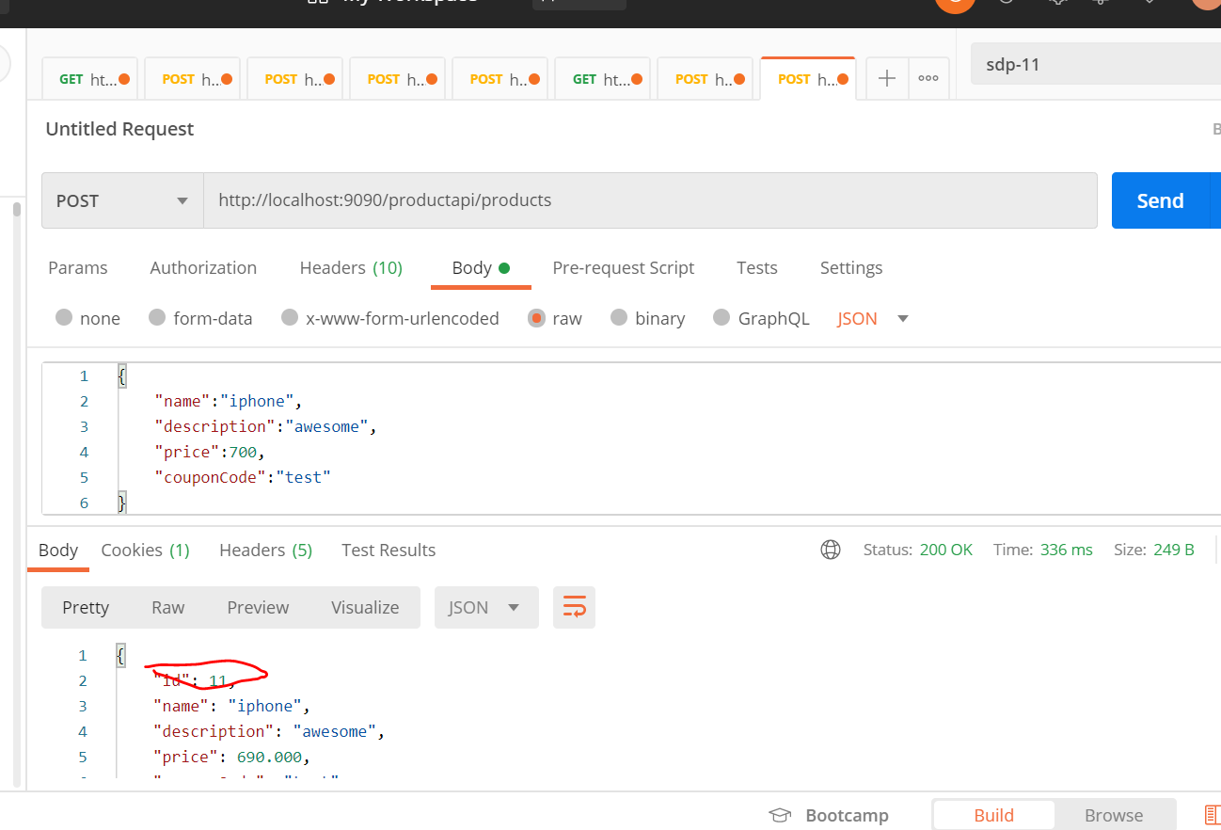

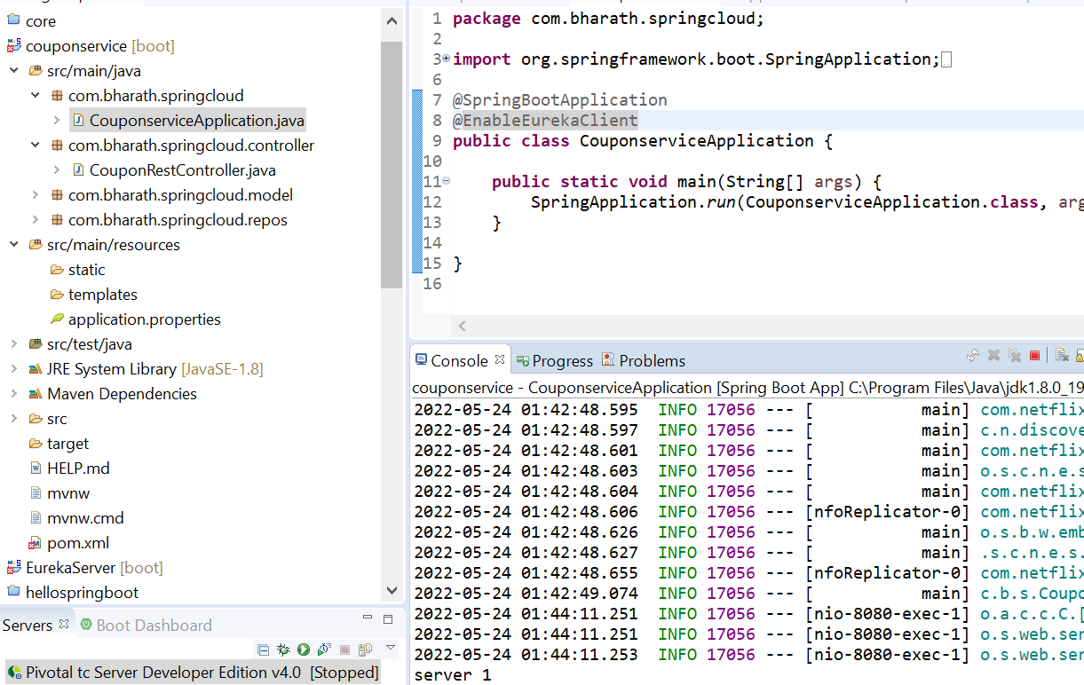

Again hit

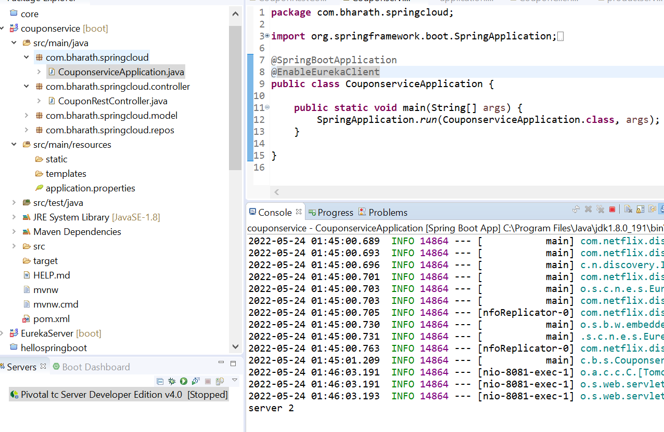

**Note :--**

load balancer component does client side load balancing

Gateway

We have non functional requirement across m/s

Security

Tracing

Service aggregation :--- client may need call to various m/s

Rate Limits

Rate limiting is **a strategy for limiting network traffic**. It puts a cap on how often someone can repeat an action within a certain timeframe – for instance, trying to log in to an account. Rate limiting can help stop certain kinds of malicious bot activity. It can also reduce strain on web servers.

A **rate** limiter that **limits** the number of requests received by the API within any given second. For most APIs, Stripe allows up to 100 read operations per second

**Note**

These all are cross cutting concern and we can configure this in spring cloud gateway and all m/s will be redirected through the gateway

If the productService want to use couponService, it need to pass through gateway, the gateway will route to couponservice get the response back and hands it to productservice. In the process it can apply any cross cutting concern

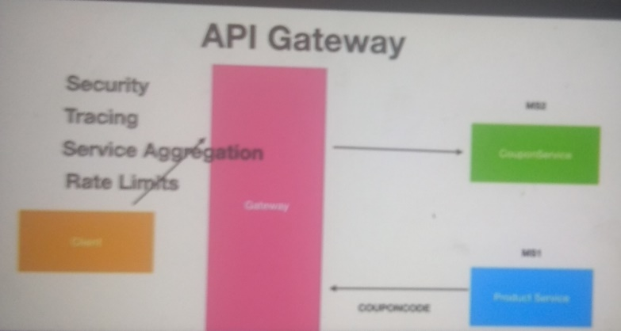

If multiple instance of m/s is running gateway will do server side load balancing for us

Note :-- preprocessing and post processing occur in gateway

**Step -1 create gateway service**

**Note :---**

our gateway will communicate to eureka server to get other info for this will add eureka discovery client

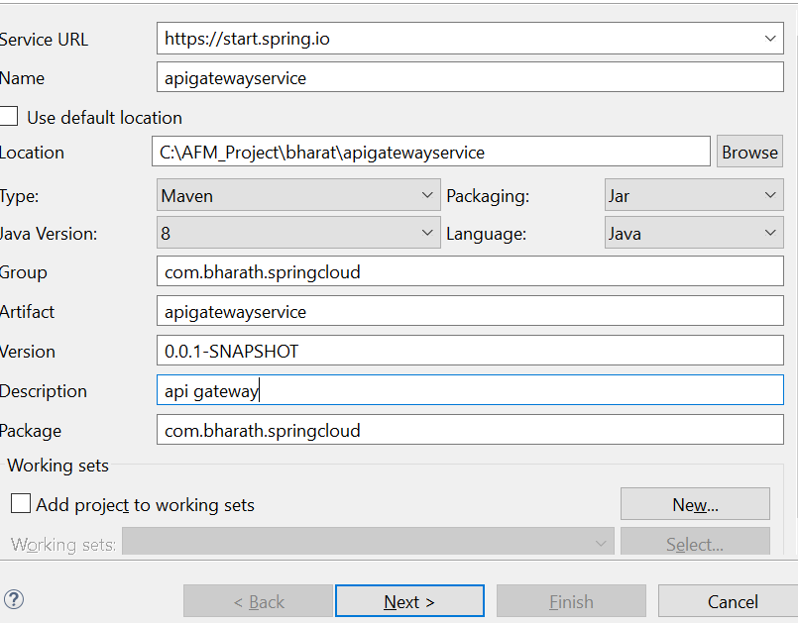

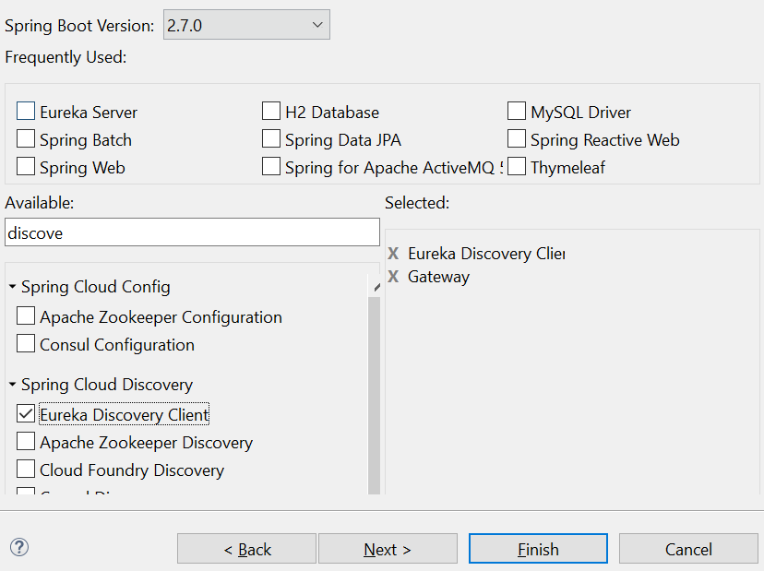

It will register in eureka server by name gateway-service

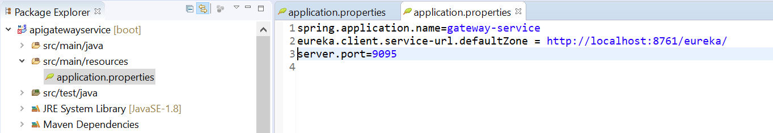

Configure the routes

We will configure ProductService and CouponService in properties file of gateway service

Notes:--

Predicate properties we will deal with path of m/s. within the coupon-service which all path is there

we can have multiple predicates so we will use [0]

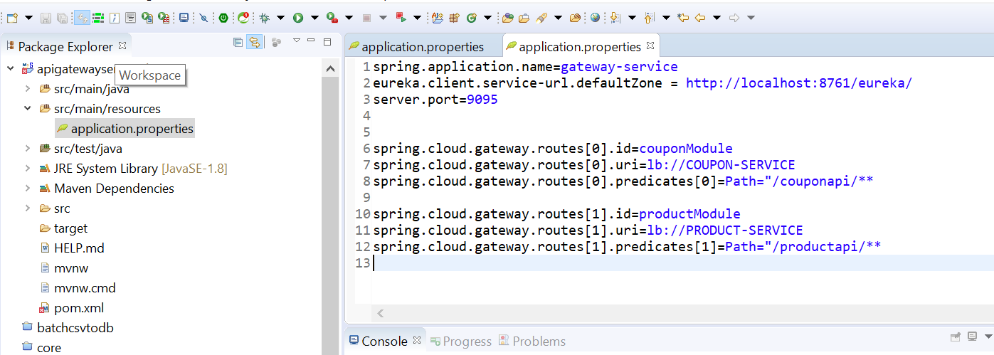

**Important point:**

Now we don’t want feignClient directly talk with eureka server , we want to route from gateway service

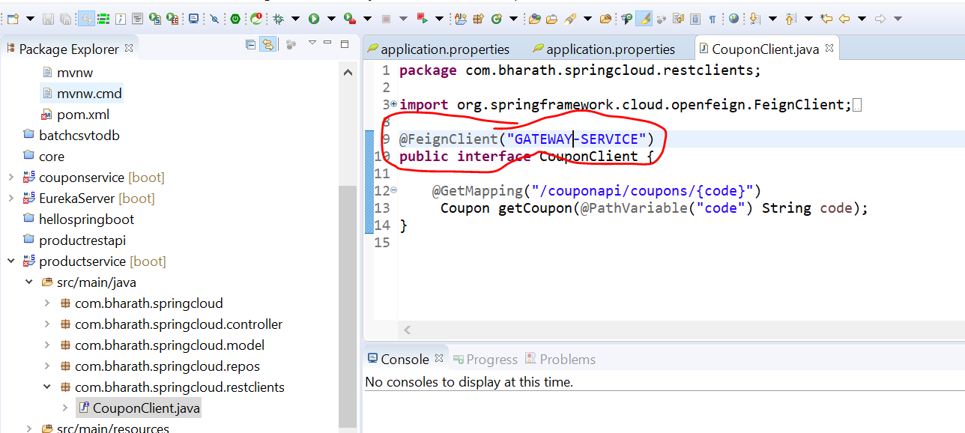

**Gateway in action**

So that it can fetch info about ProductService and CouponService

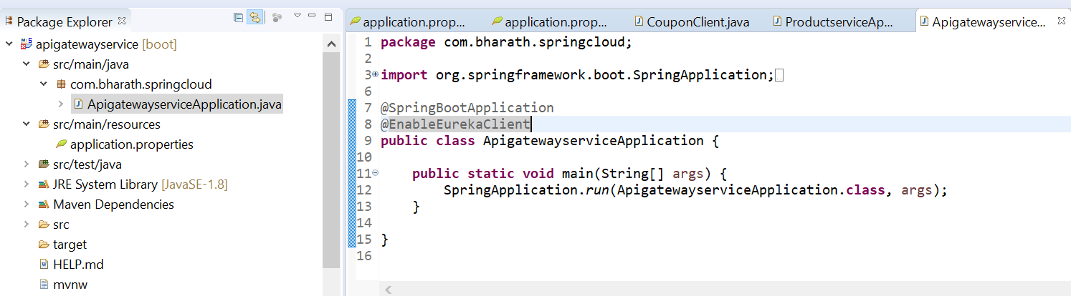

**Now for m/s will be there**

EurekaServer

ProductService

CouponService

Apigatewayservice

Put this property in both m/s ProductService and CouponService

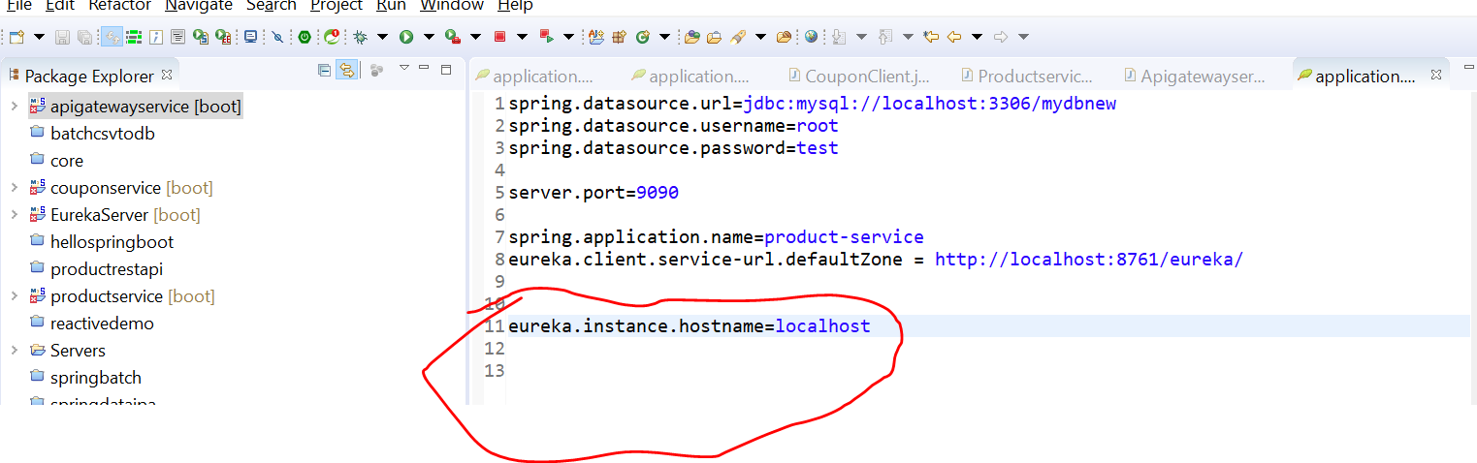

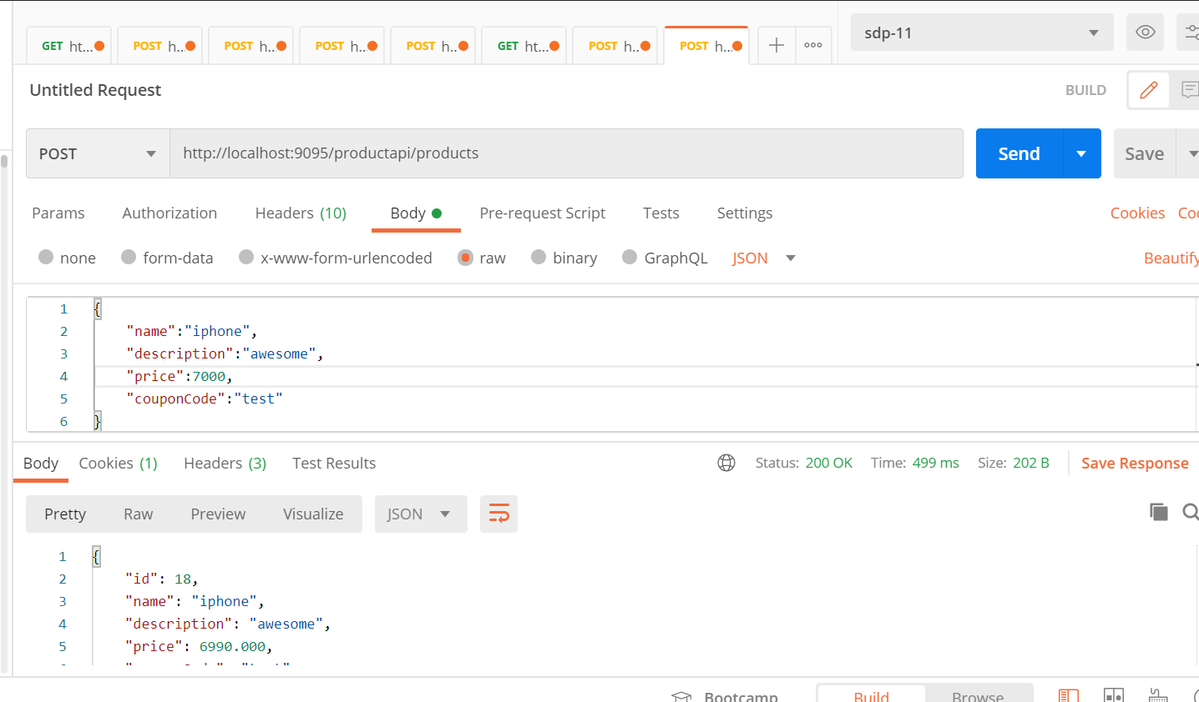

Now everything is happening through gateway

What is Eureka instance hostname?

If the hostname cannot be determined by Java, then the IP address is sent to Eureka. **Only explict way of setting the hostname is by setting eureka.** **instance.** **hostname property**

**Filter Introduction**

**Note**

The api gateway allow us to do cross cutting concern like security using filter classes

Whenever request come from any m/s to api gateway it will invoke filter where we can do pre and post processing logic

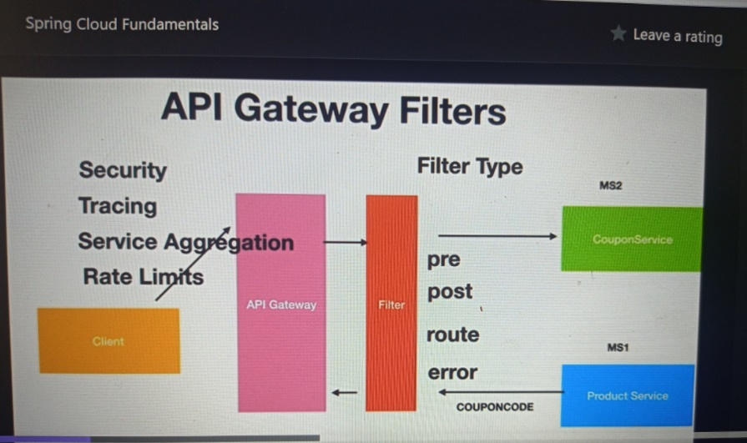

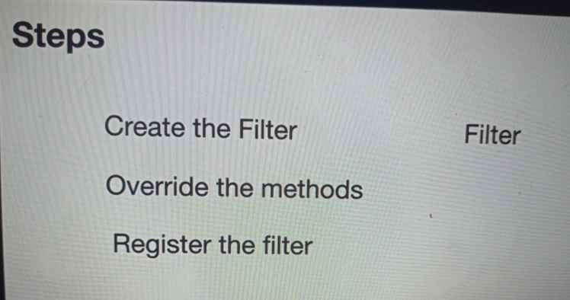

**ServerWebExchange** :---- this guy will both have request and response information use in filter arg

**GatewayFilterChain** :-- we can have many filter before it hit to m/s. this have all info where to go next and last it will reach m/s

Any preprocessing logic will put before chain.filter and after that post processing like encryption, zip the response

**Use Custom Filter**

**Now for m/s will be there need to run all 4**

EurekaServer

ProductService

CouponService

Apigatewayservice

**Chain.filter(exchange)----------**

this will pass to next filter and if it is not there it will get m/s eventually

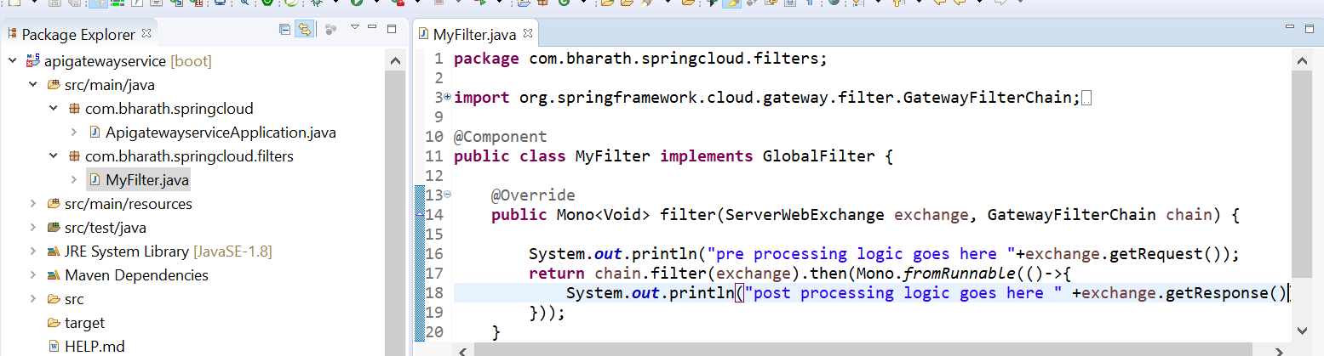

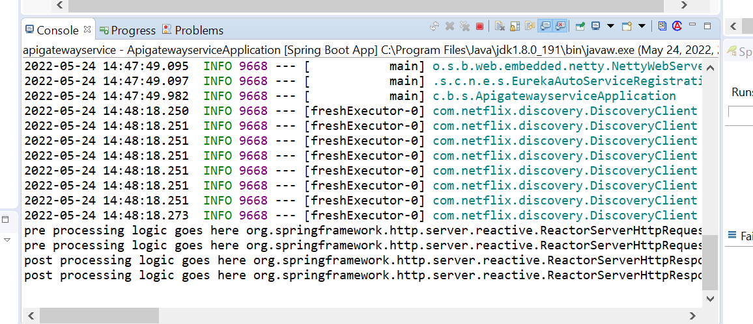

Resilence4j - Fault Tolerance

1-When multiple m/s run and one of them goes down we don’t want entire application goes down.

1. Like here if couponService goes down we don’t want ProductService also goes down , we want productservice Retry and handle the exception gracefully that is where Resilence4j component and it allows our application to do fault tolerance

**Configure Retries**

**How to configure fault tolerance or resilence4j for our ProductService if one m/s is down**

**Step 1 :-- add the dependency**

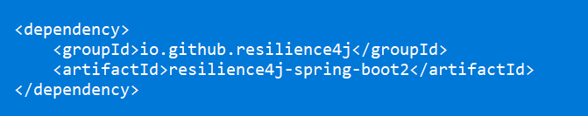

**Note :--**

when couponService is down then productService will get fail want to retry couple of times

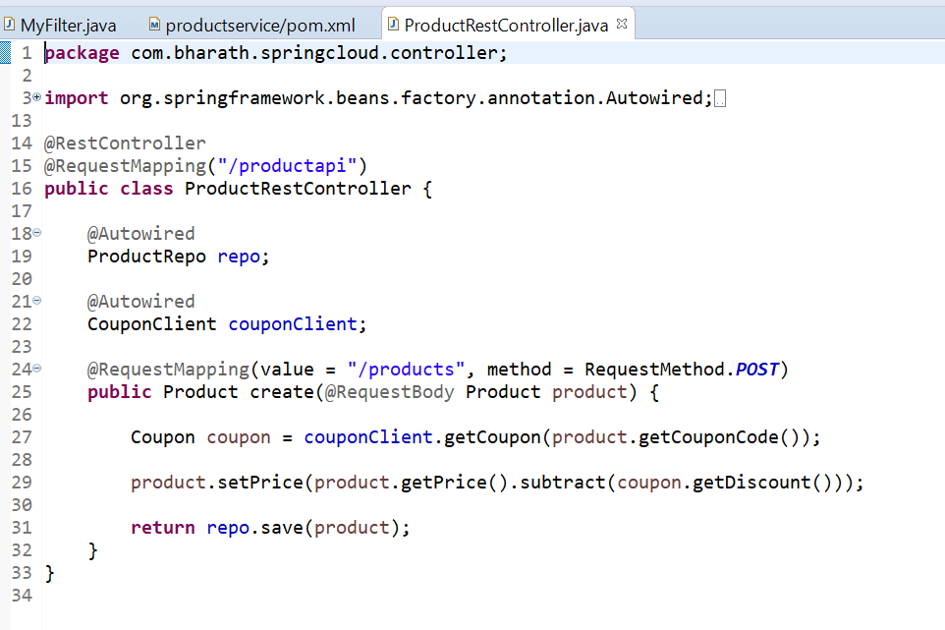

**Note :**

By default retry will occur three times whenever failure occurs

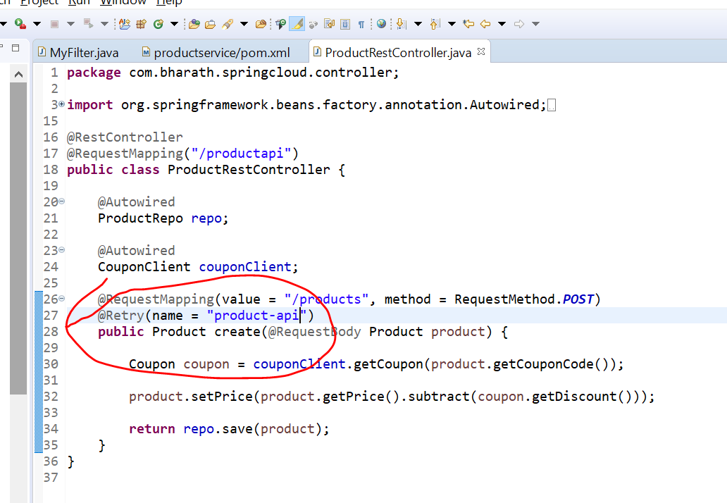

**Note :**

We can configure exception also for which retry will occur

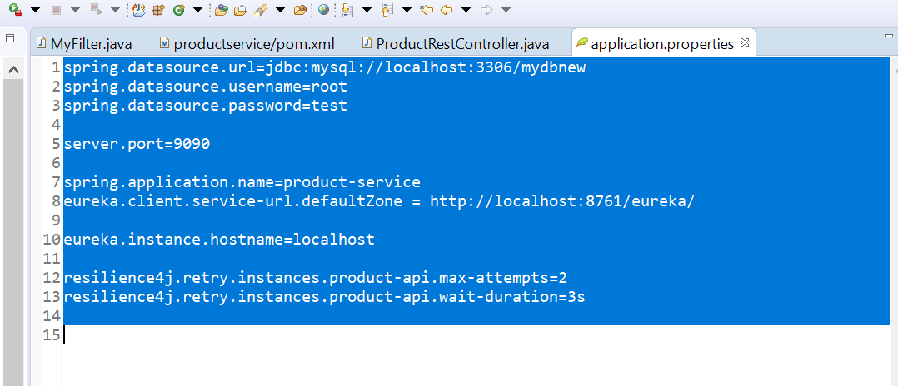

**Removed i from couponapi**

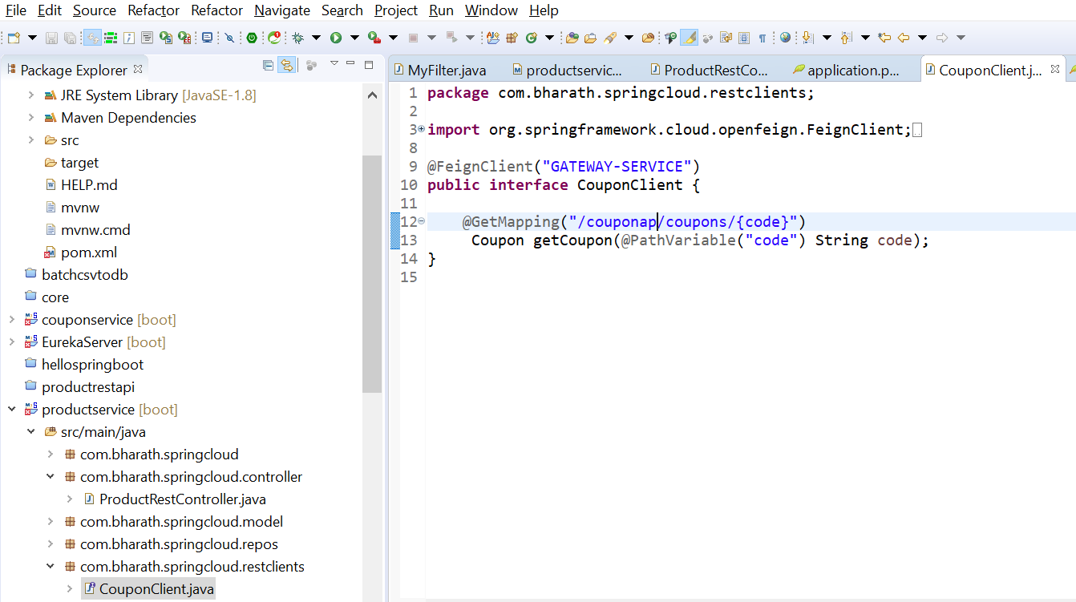

**Now when we run test case from postman**

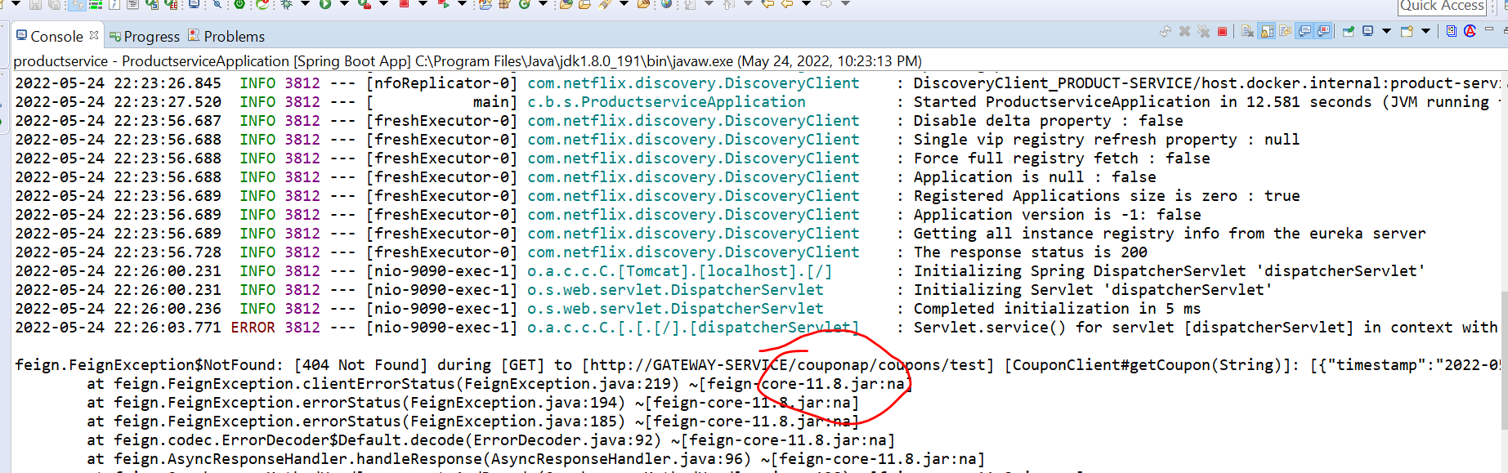

**Use Fallback Methods**

Send a graceful error if retry is happening and failing

Instead of sending exception we can create a fallback method

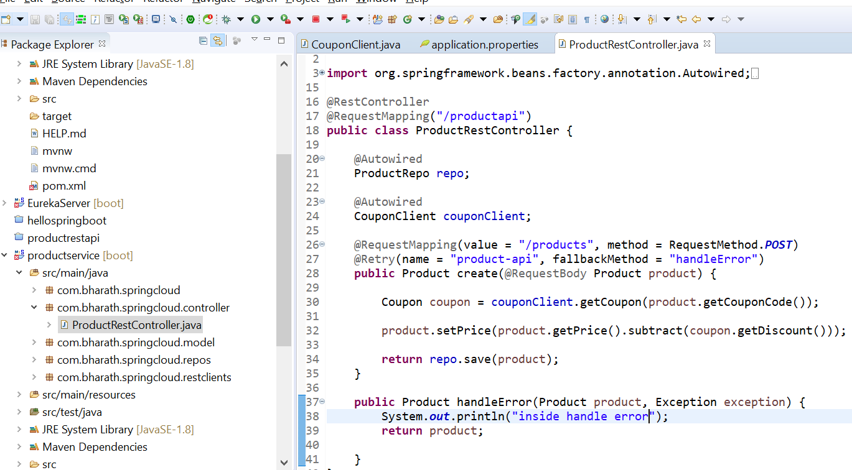

So whatever exception will come that will automatically catch in exception object.

And wtever product we are sending that will return back

**NOTE:**

**Even after couple of retry if still it fails then fallback method will get call**

Since we are not saving in d/b so id null will get

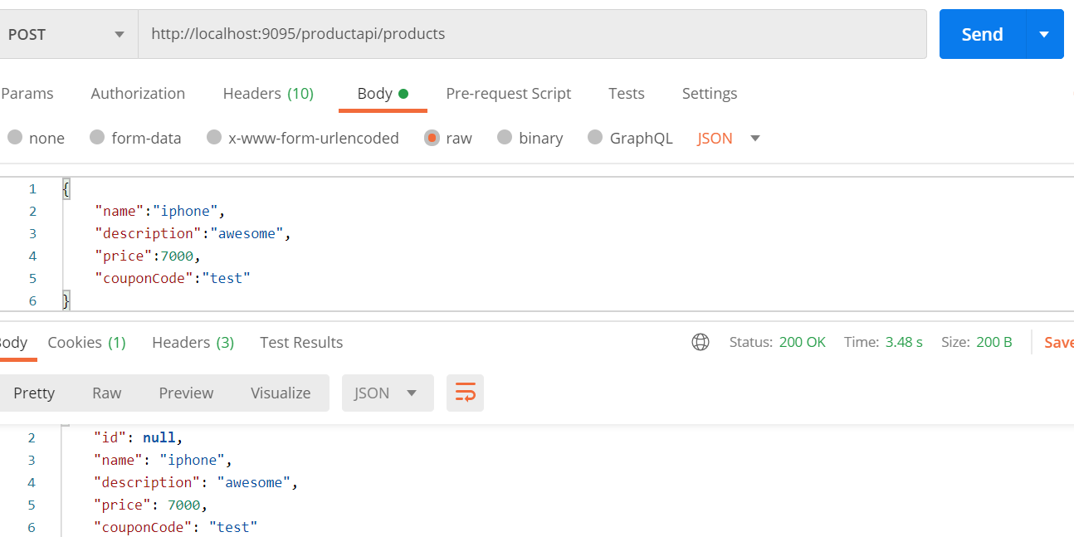

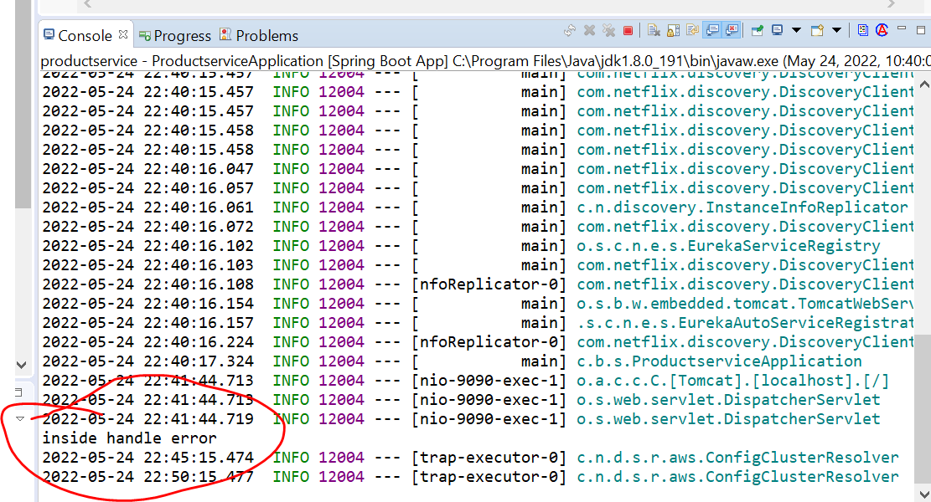

---- While using resilence4j the method that handles the faults(fallback method) should have the same signature as the original method

Sleuth and Zipkin

When lot of m/s is running we should able to trace all client request and where it is going and when it fails

We can know where exactly it fails so sleuth and zipkin provide distributed tracing capability.

**Sleu**th will add trace id to http headers. As the request flow sleuth is responsible for adding the trace id to the http headers

**Zipkin** is responsible for providing the dashboard where all the trace id is exported

**Add sleuth and Zipkin support**

Request flow always start from api gateway

<http://localhost:9095/productapi/products---------------9095> port of api gateway

**Request----api gateway----productService-------apiagteway--------couponservice**

**Note:** we are going to track all these flow using sleuth and display using zipkin

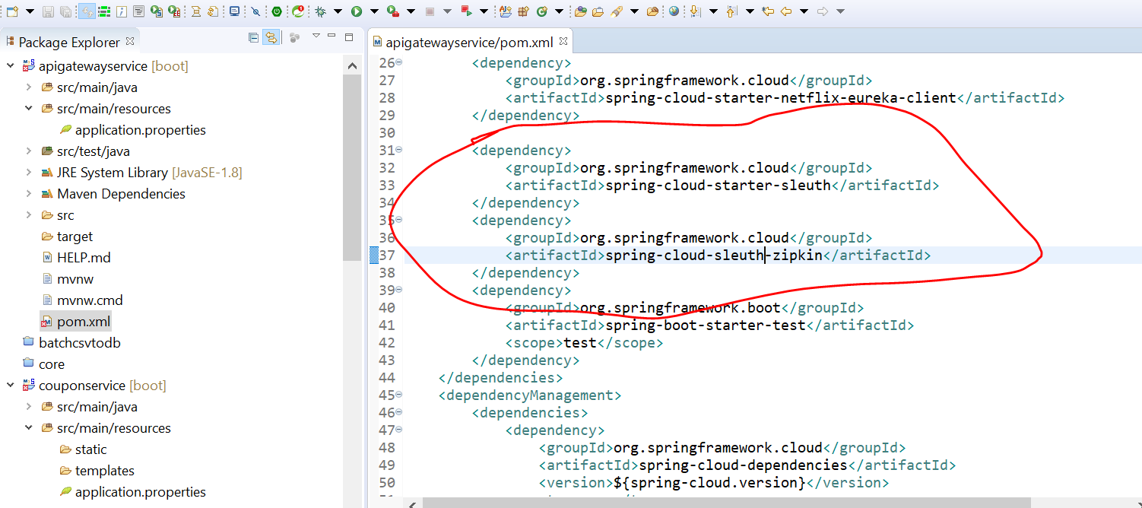

**Sleuth** is responsible for adding trace id to the http headers when request flow from one m/s to other

**Zipkin** is responsible for aggregating those traces and display on dashboard

Will copy these 2 dependencies in all project so that trace will go from one application to another

**Note:**

**We added dependency in** apigatewayservice , productservice, couponservice

Step :-

Start zipkin server

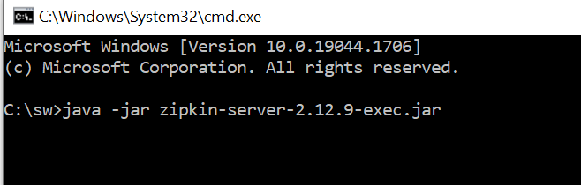

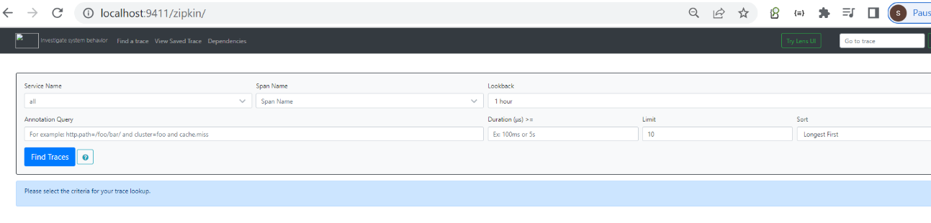

Notes: ---- once we add couple of properties in application all these traces can be seen here

**Distributed tracing in action**

Note :

When we add zipkin dependency in project, zipkin knows by default it will run in port 9411

Automatically pushes the traces to server

**Start in this order**

Eureka server

Couponservice

Productservice

Apigateway

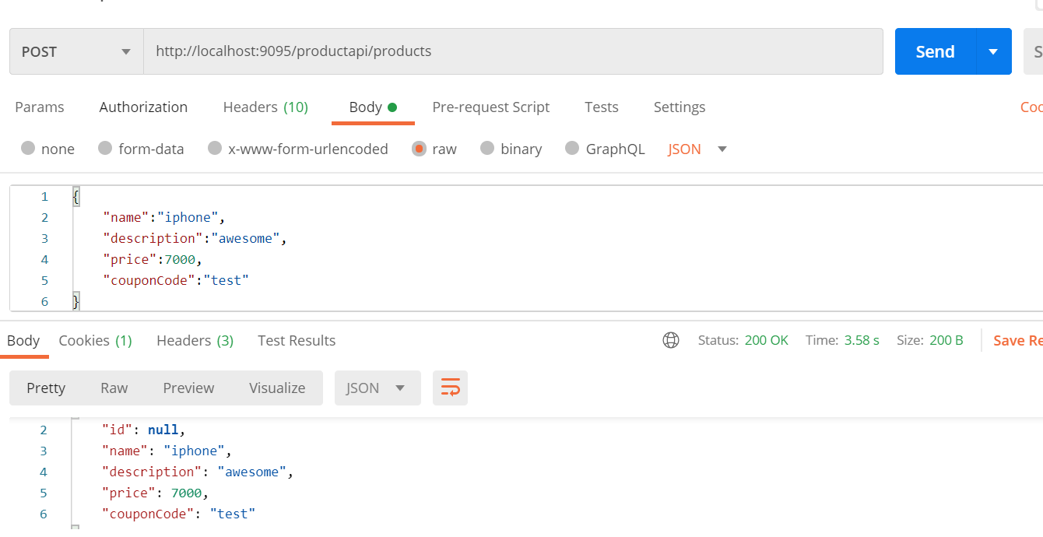

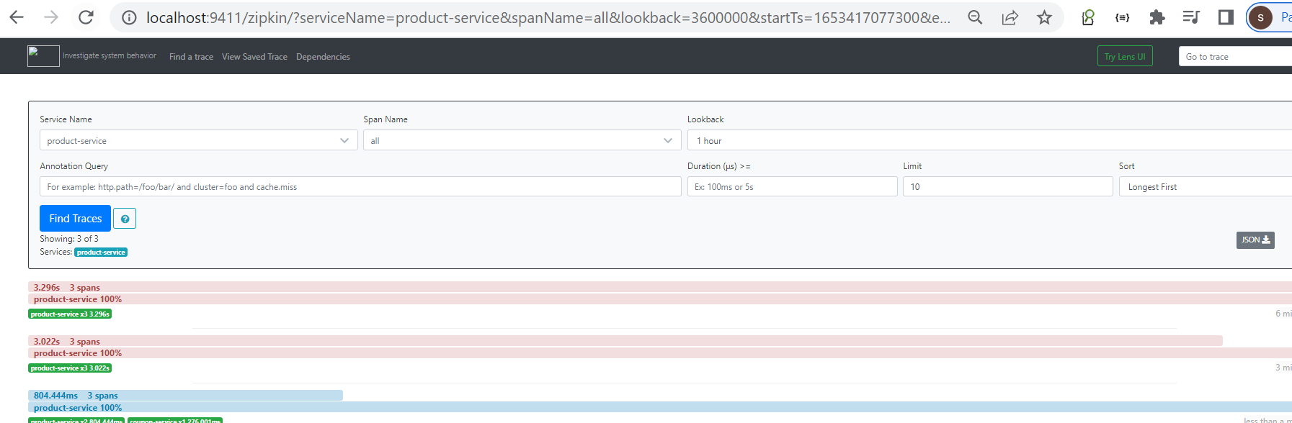

Centralized Configuration

**Imp points**

Every m/s will have configuration associated with it

This could be :----DB configuration , Message broker info, application configuration

This info will be different for different environment :---local ,dev,test,staging, production

**Each application can have multiple properties file**

**It is our responsibility** to push right configuration across the env that is where Centralized Configuration comes in picture

**Note**

**Spring cloud provided configuration server.** All the m/s will get configuration info for right environment from configuration server. If application deploy in dev the appropriate configuration will be provided by configuration server

How configuration will know about correct configuration. As developer we will push all configuration to git

Repository and configuration server how to connect to git repository and it will pull the information share it across the m/s

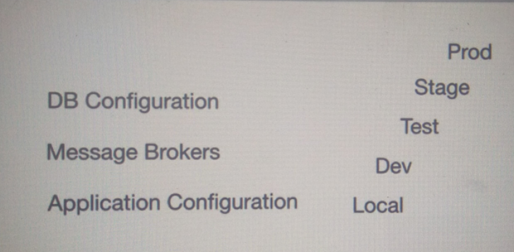

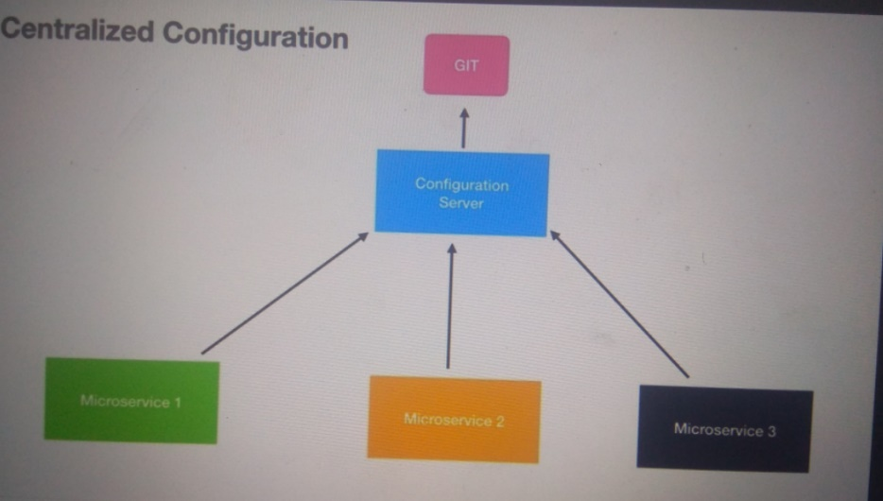

Configuration server is responsible for maintaining and handing over correct configuration to correct m/s

Depending on the env

**Steps**

**Create config server**

**Create config repository :---** will create local git repo

**Create config client ------**m/s application which will be configured to use config server

**Step 1 ---- create Config server**

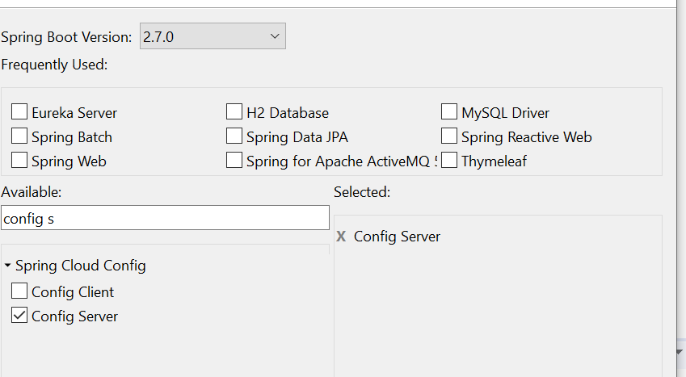

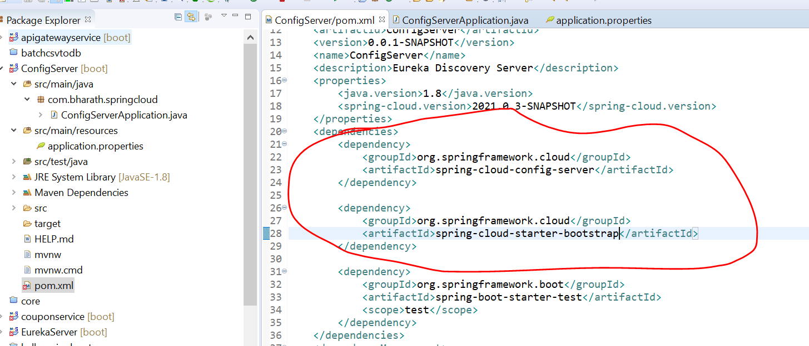

**To make this project as config server**

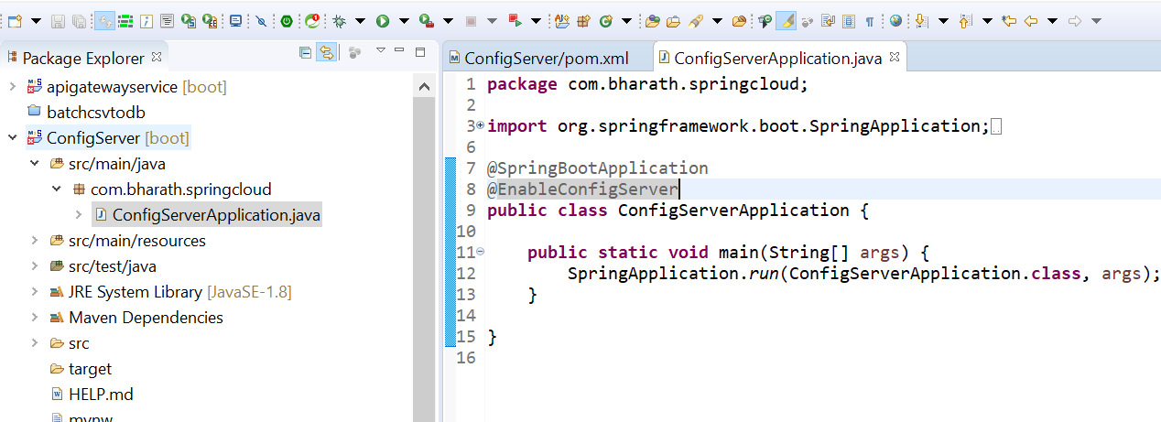

**Couple of properties need to add**

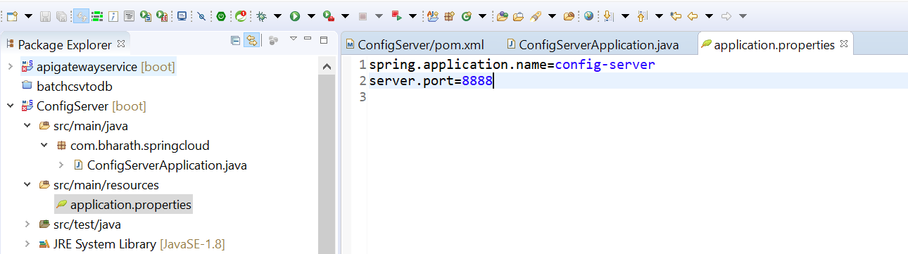

**Create Local Configuration**

**Config server will pull all configuration info from git or centralized git repository**

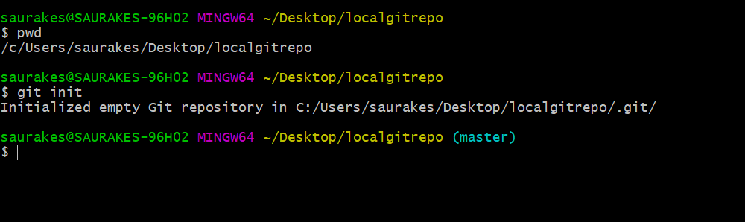

**Name of properties file should be saved by microservice name :----- product-service.properties**

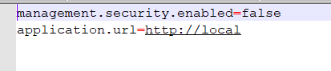

There is no need of security so we added **management.security.enabled=false**

**Created a local git repo** and added default properties file that will be use later by product-service

And also commited file in local git repository

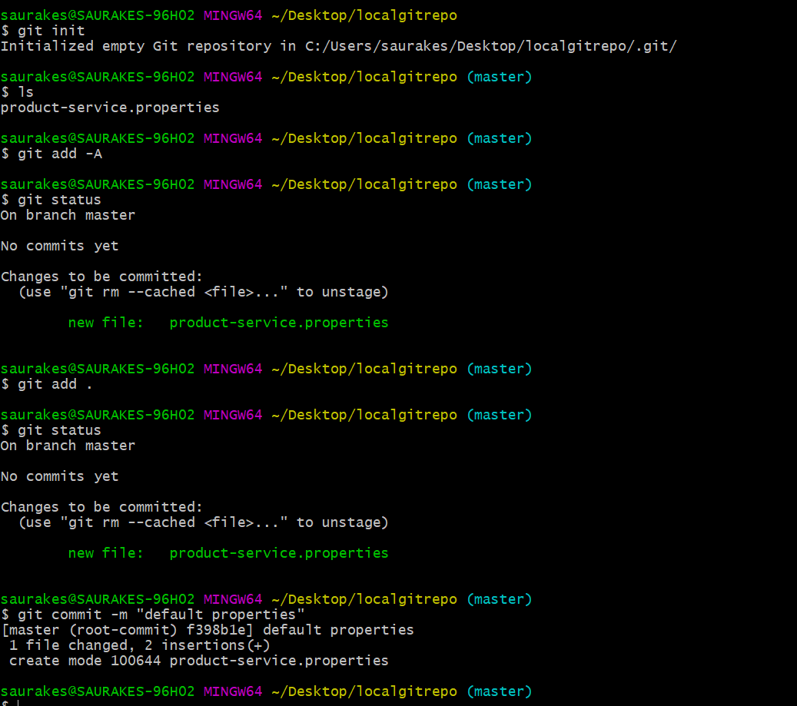

**Access Default Configuration**

**Will connect config server to git repository**

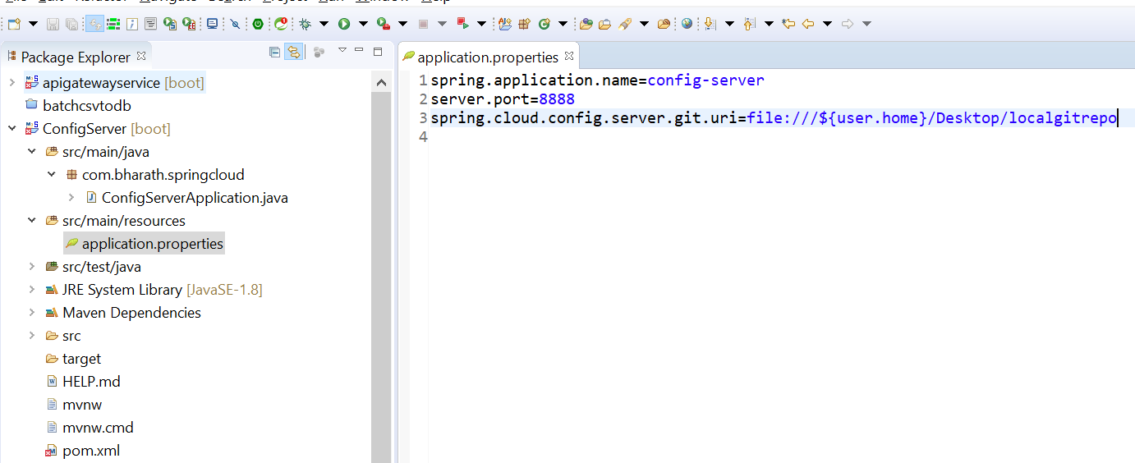

**Note :---**

now the config server knows where to find the configuration file

**Imp :-** Once we will run config server it will expose properties file into that server

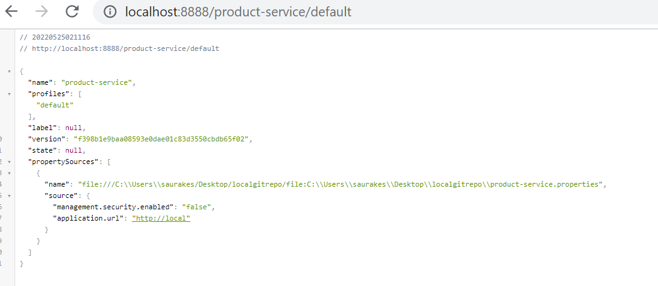

**Note :---**

later we can use this in productService once we make it configuration client

This will become default profile

If we don’t give any hyfen extension it will become a default profile

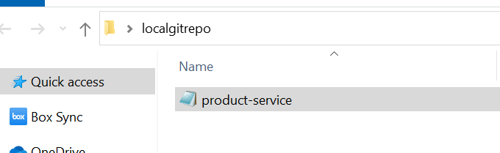

**Configure dev Configuration**

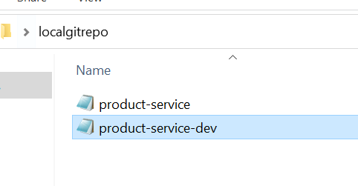

Now commit this file in git

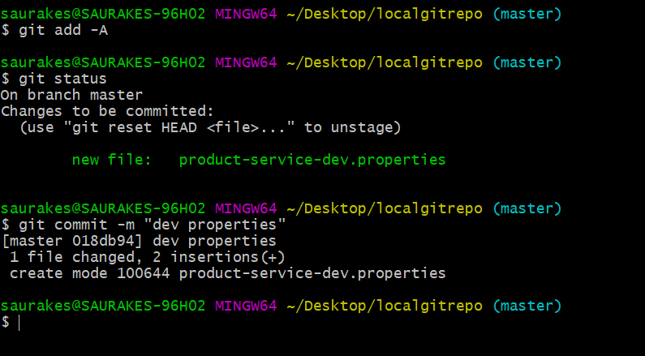

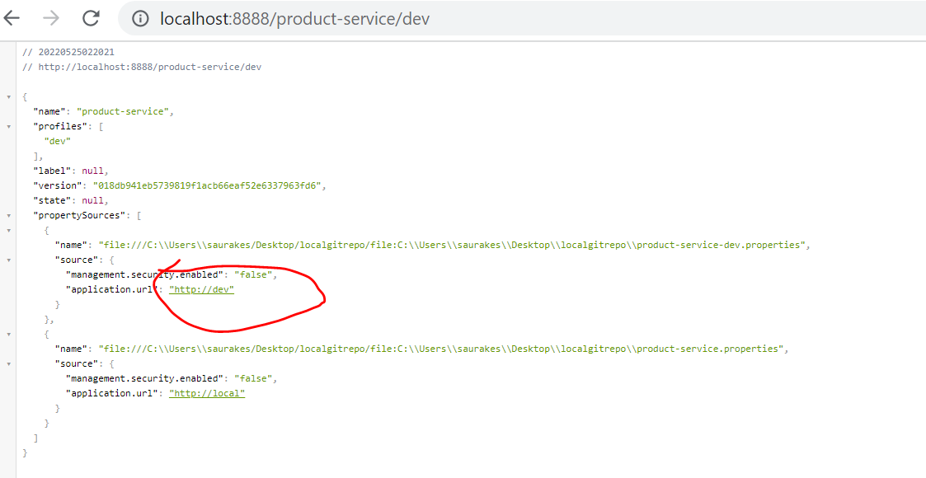

**Note :---** default properties is available in all the profiles

Basically we are exposing configuration file from git into config server

**Configure Config Client**

Now we have configuration server up and running which can access a git repository

**Requirement** :--- ProductService will use config server

Any m/s can use this config server

**Add this dependency in pom.xml of ProductService**

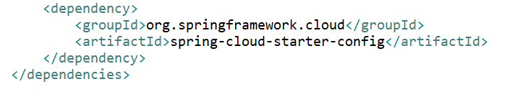

**Note :**

we can comment all these in properties file and add this localgitrepo product-service.properties file

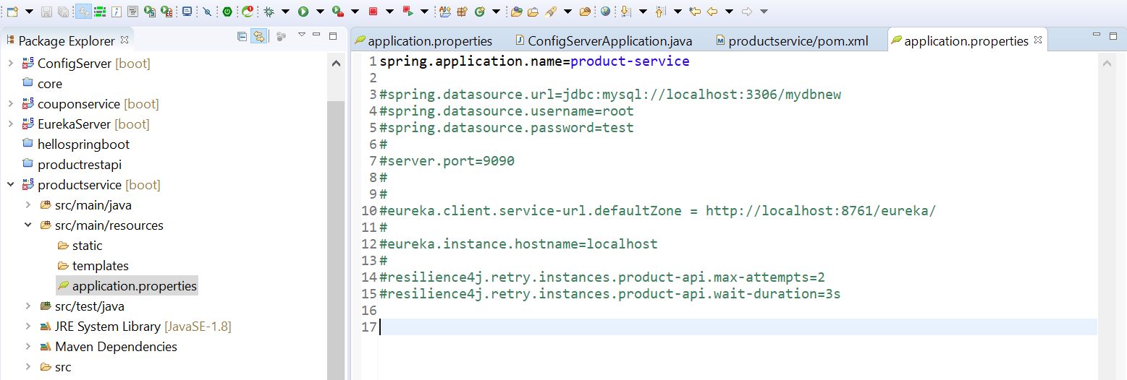

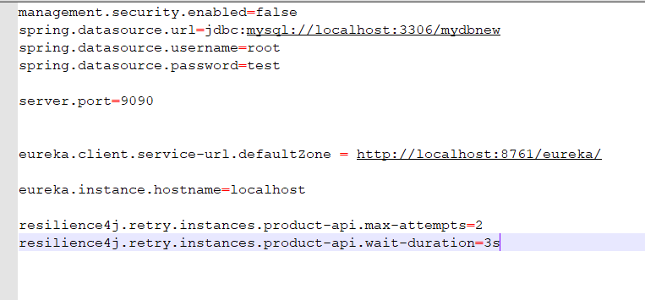

**Note :**

we need to tell from where fetch the properties file info

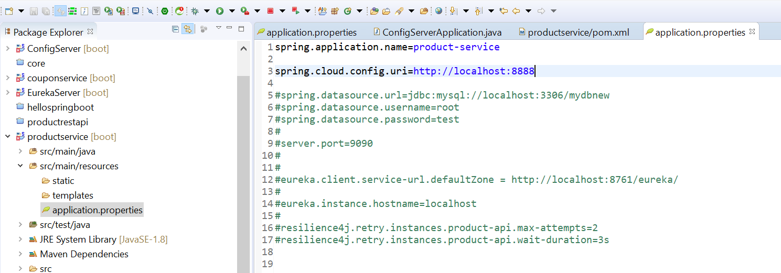

**Test Config Client**

**Note:**

The application.properties need to rename as bootstrap.properties in ProductService

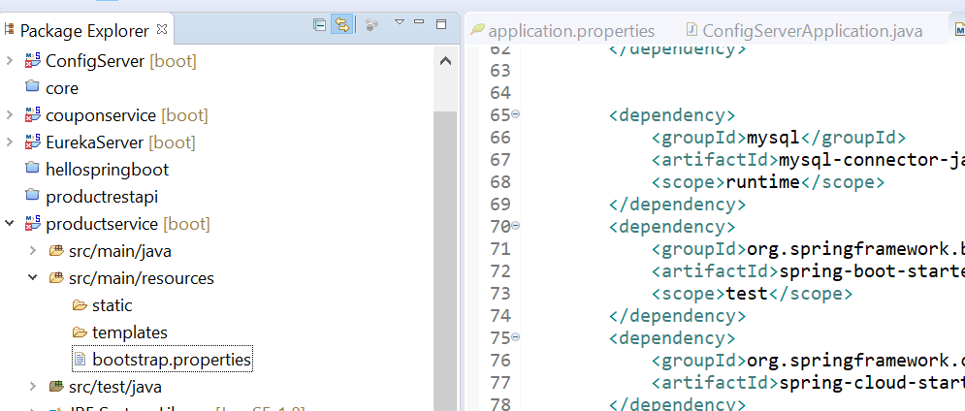

Add this in productservice pom.xml

<dependency><groupId>org.springframework.cloud</groupId><artifactId>spring-cloud-starter-bootstrap</artifactId></dependency>

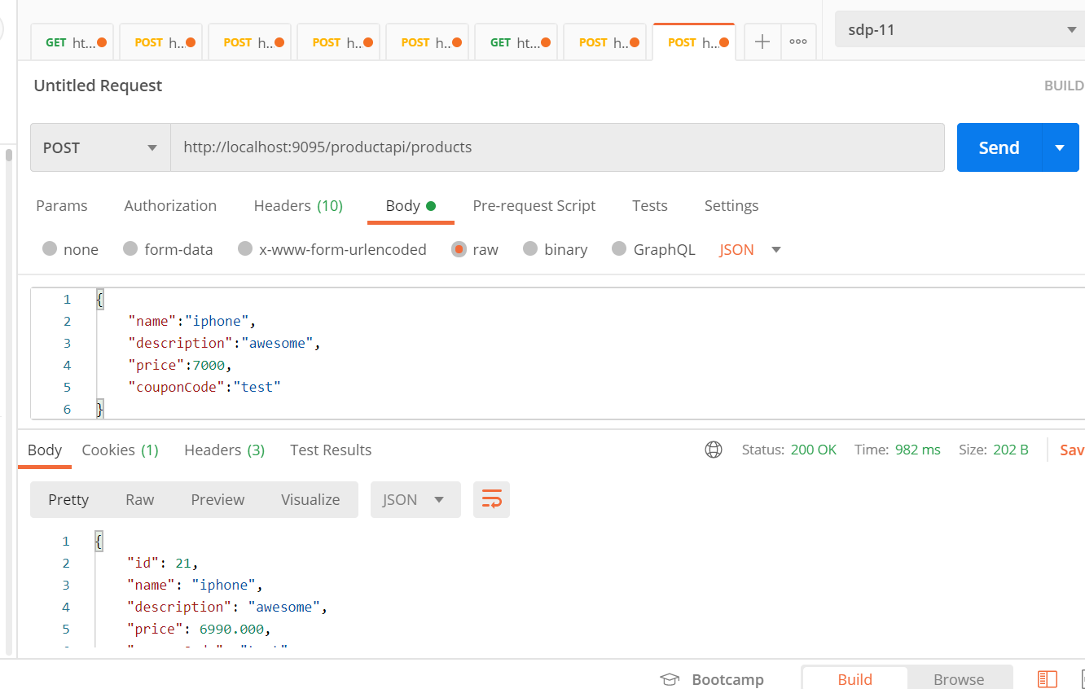

Now configuration is fetching from config server

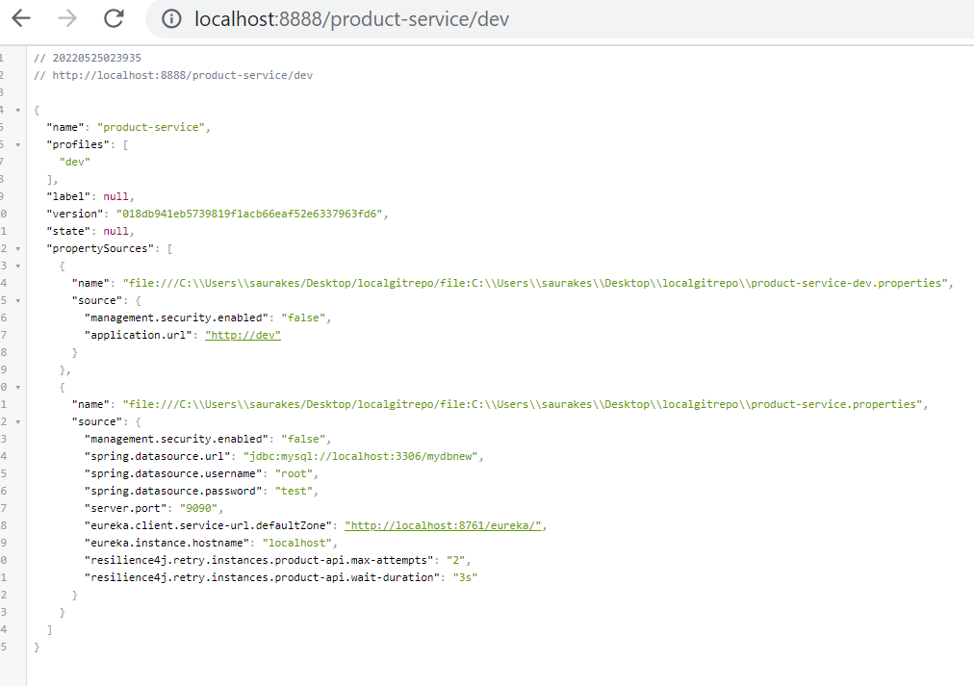

***Activate Dev Profile***

**How to access other profile if env changes from local to dev**

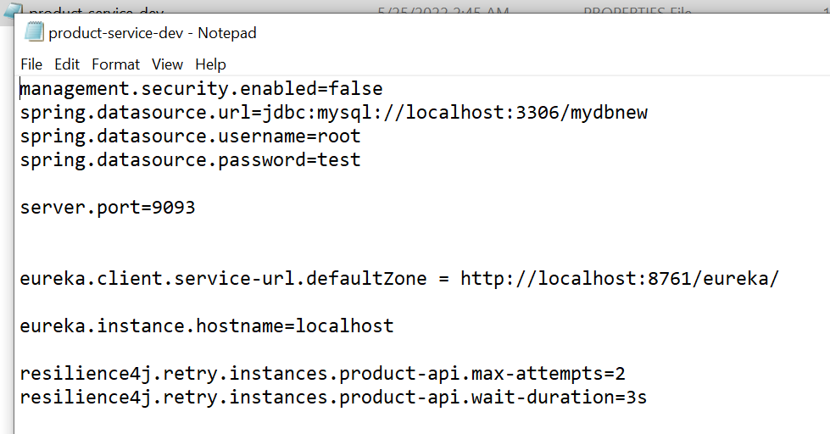

By default if we don’t activate a profile it will pick up default one

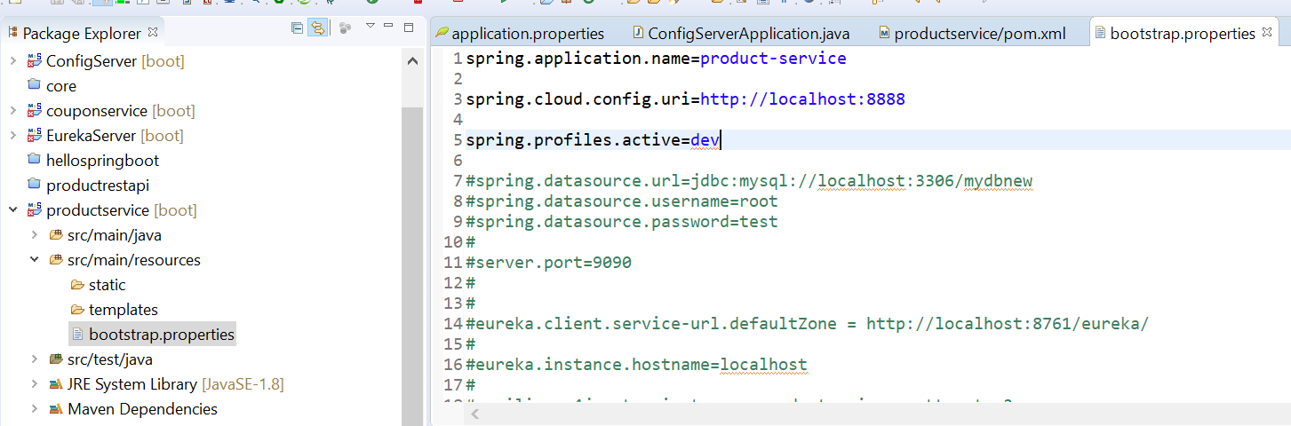

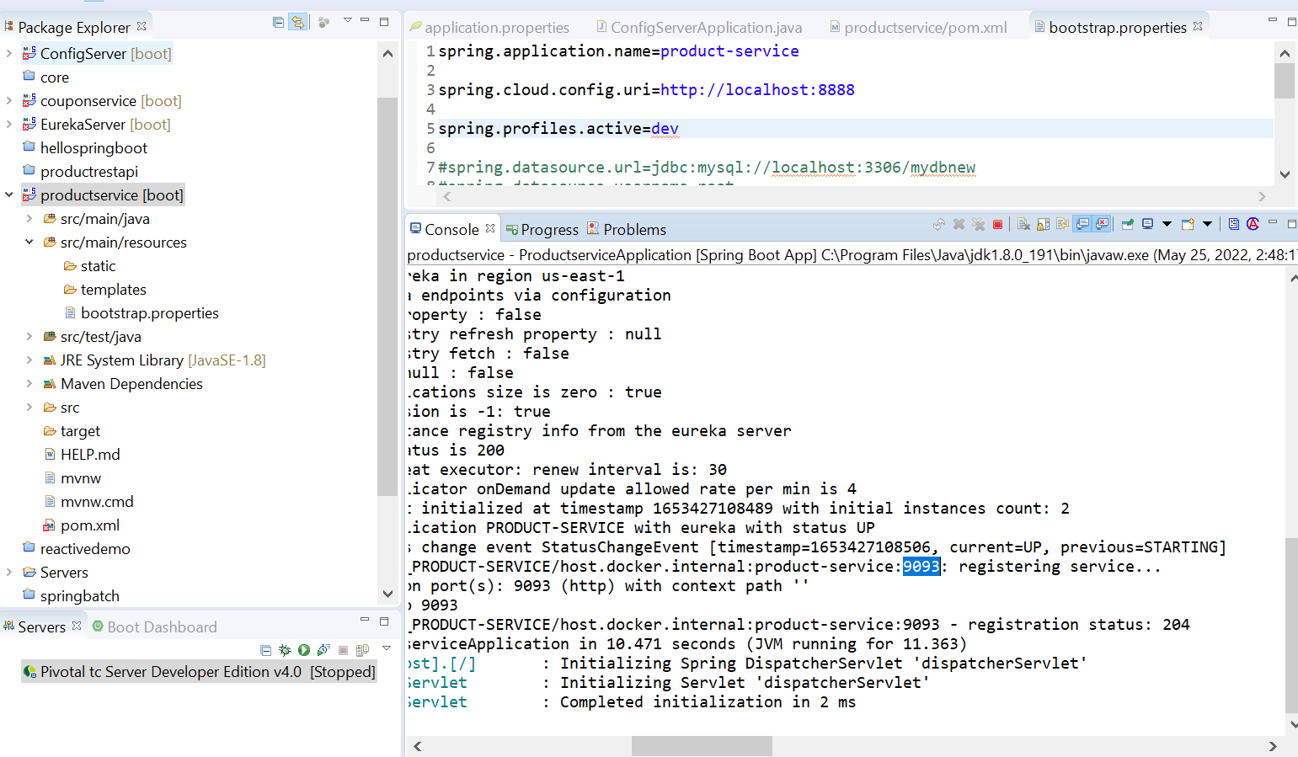

Dev- profile is activated at 9093

Spring cloud bus

Will see a problem when using config server and that problem we resolve with using cloud bus

Note :

Once we use spring cloud bus, all configuration of of diff instance of same m/s will get updated by single refresh

**First we will see the problem then we will solve using spring cloud bus**

**Use a custom property**

**Step :1**

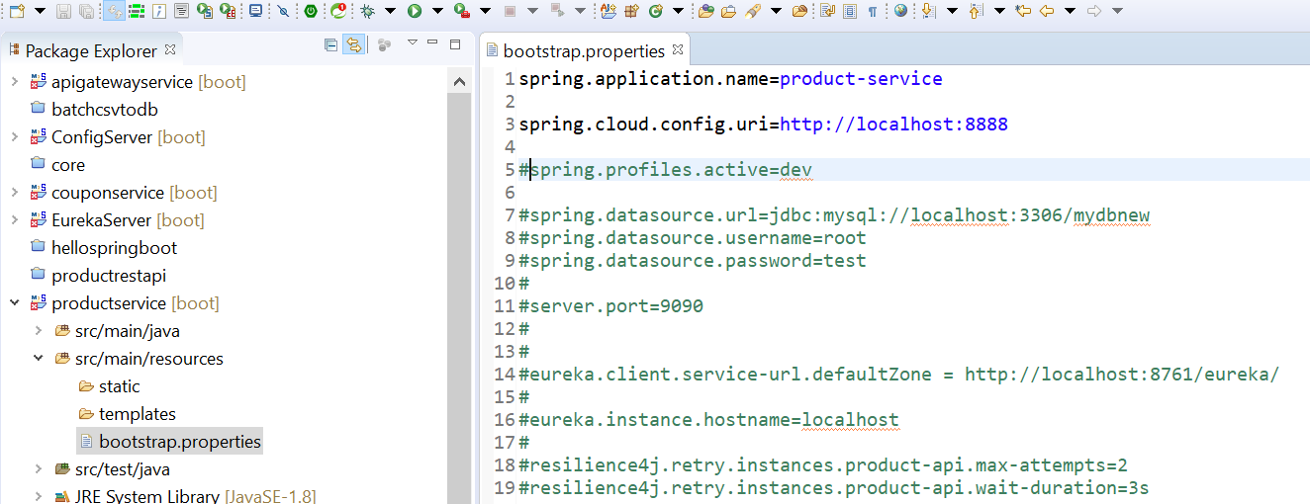

**Step 2:-- go to local git repo**

Add custom property

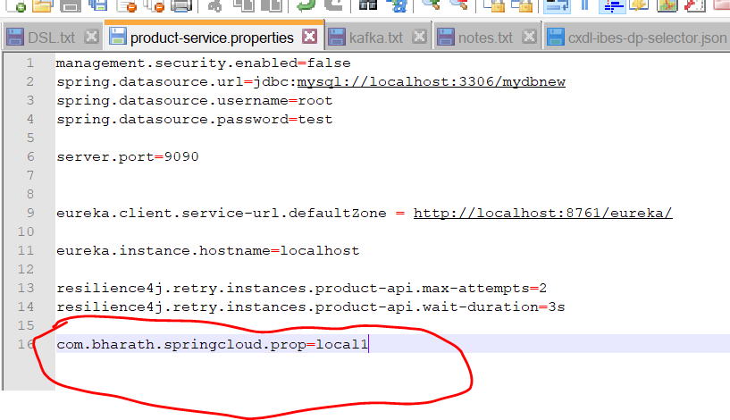

Injected the property at prop from properties file due to value annotation and also expose it restful endpoint

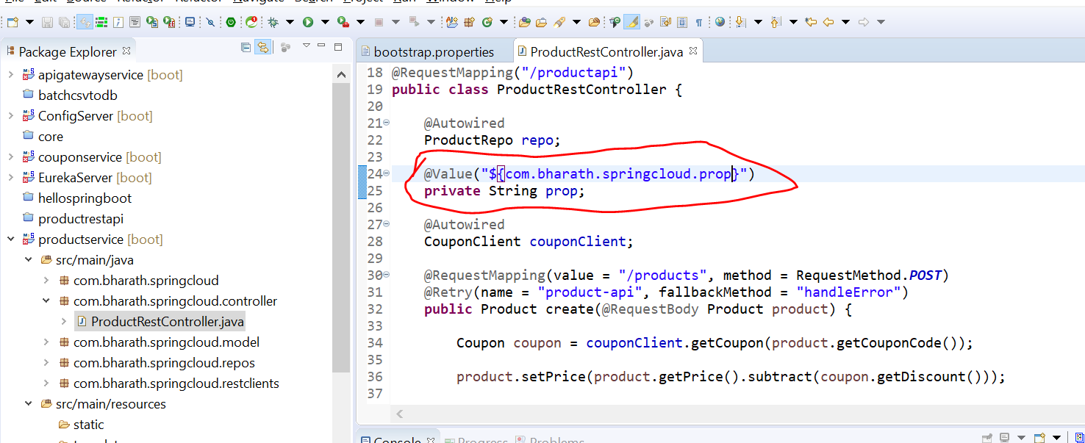

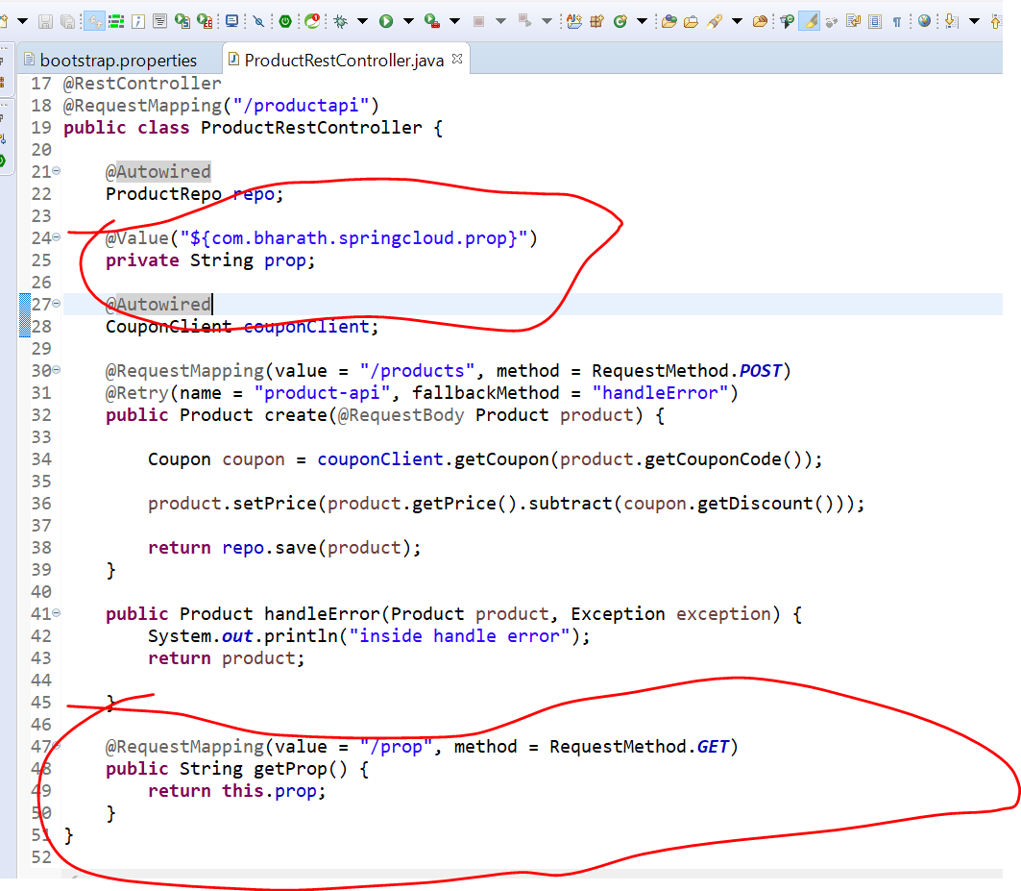

**Enable Config Refresh**

Will enable refresh endpoints for ProductService m/s

Step 1:---- go to ProductService in localgitrepo and enable actuator endpoint for our application

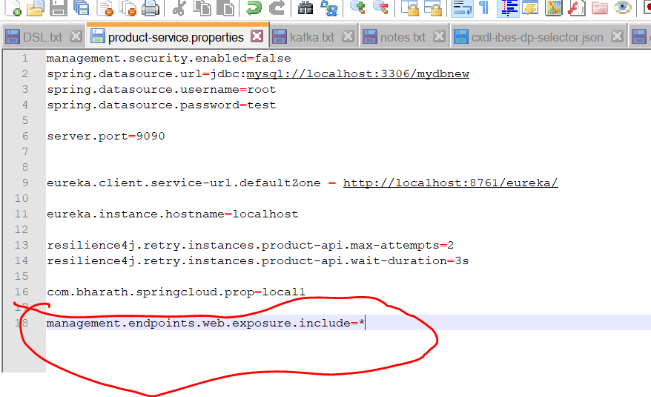

**Step 2**

Note :- for repo value to get updated we need to mark@RefreshScope in controller class

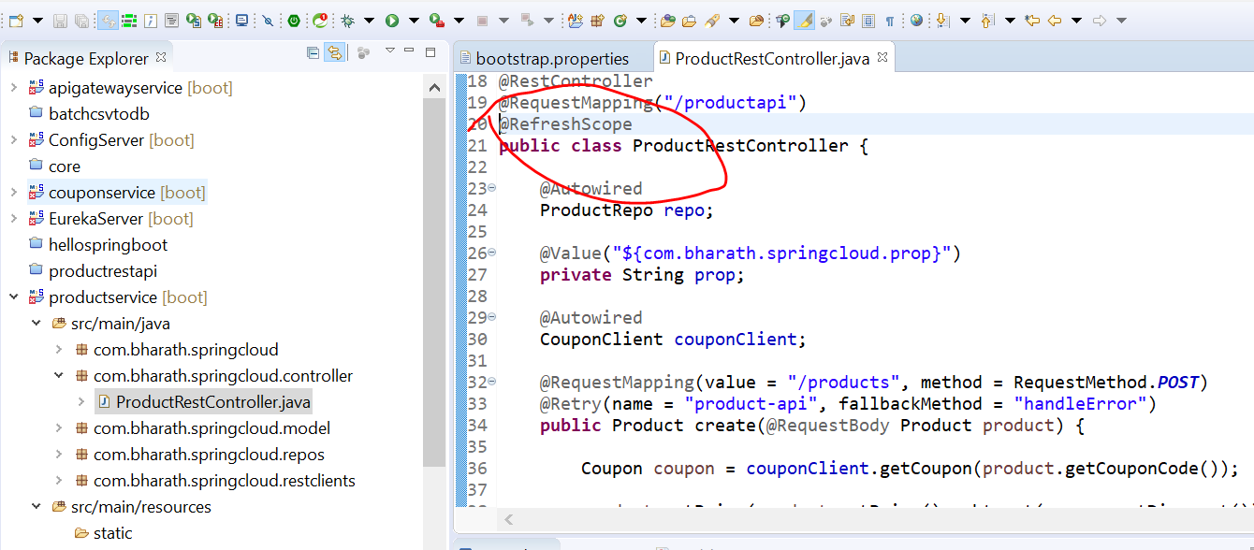

**The Global Refresh Problem**

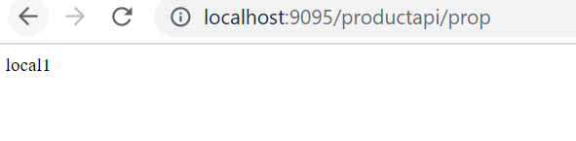

**Eurekaserver----Apigatewayservice -----configserver----ProductService -----couponService**

**Will run apigatewayservice in url from there it will check application name in eureka then it go ProductService**

**And from there it will fetch configuration file by configserver which is pointed by application.properties of ProductService**

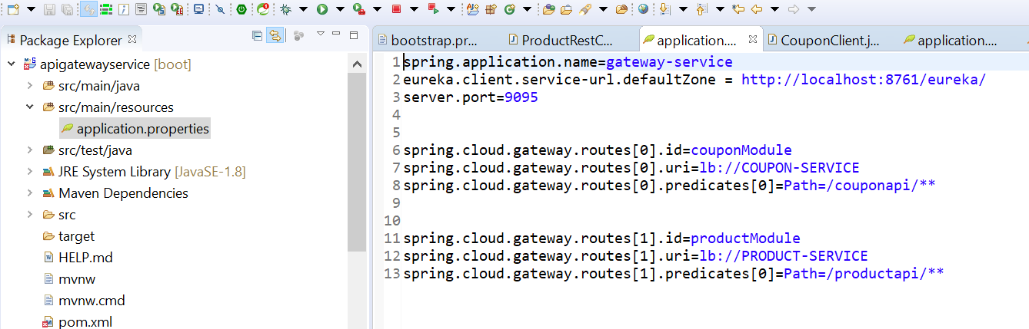

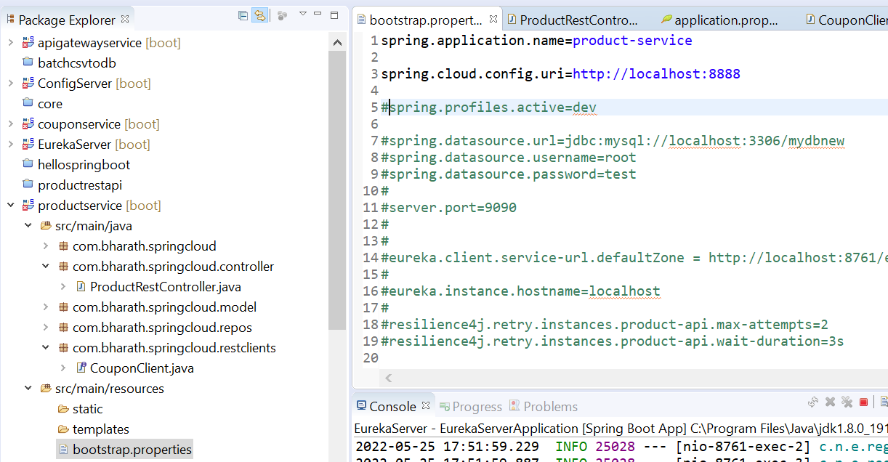

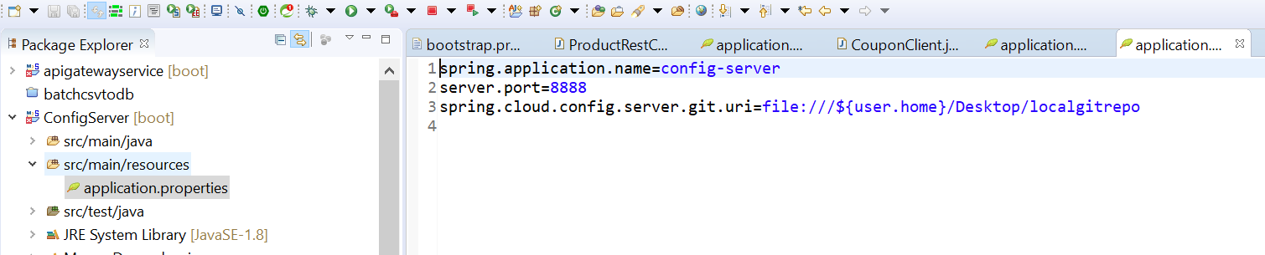

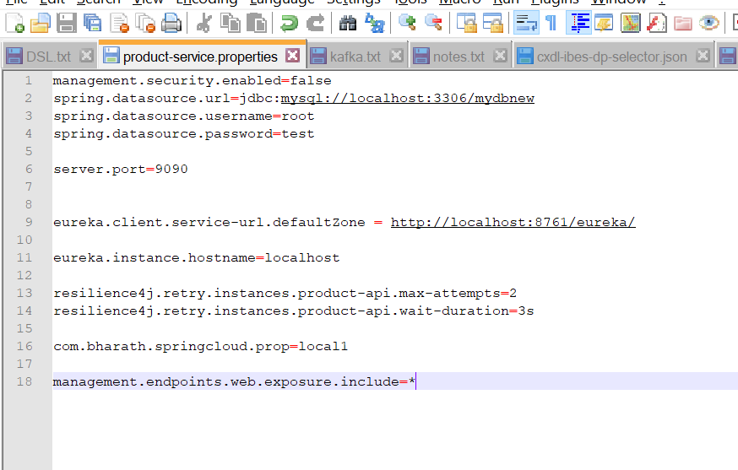

**Change the value in product-service.properties**

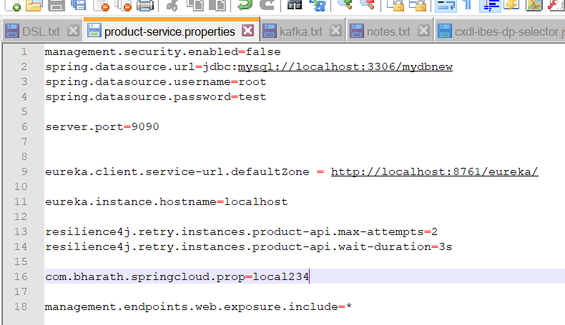

**Refresh this still seeing the same value and all server started**

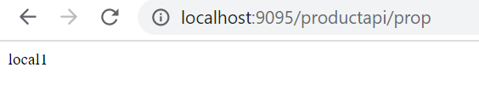

New value is not picked up that is the reason we enable actuator

Added actuator in pom.xml of ProductService

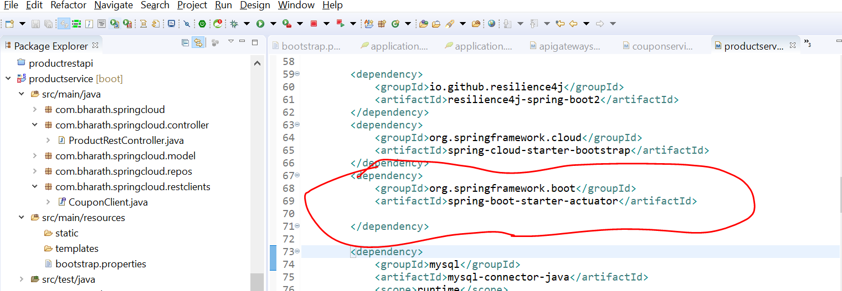

Now if we change prop value in properties file and run this

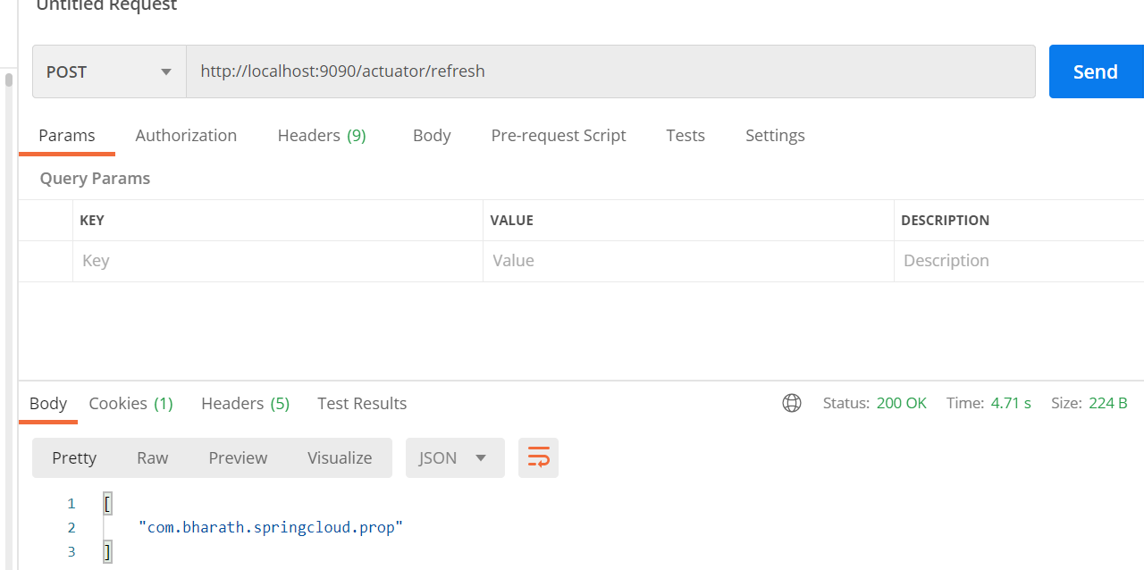

And again hit url value will get updated without stopping server

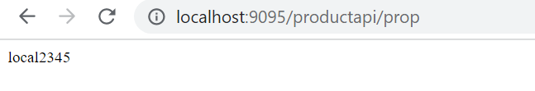

Problem :--- it only do refresh for one m/s which we are running . If 100 m/s is there then we need to do 100 times. This is actual refresh problem

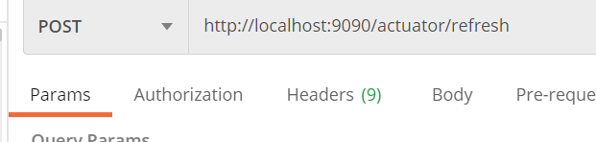

**That is where cloud bus come in picture once we refresh at single level it will refresh all m/s instances**

**Into spring cloud bus**

**Imp**

All the m/s in touch with cloud bus and cloud bus in touch with config server. So if any configuration changes

Then actuator/bus-refresh done and cloud bus will tell all other microservice through message broker like rabit mq ( configuration got changed)

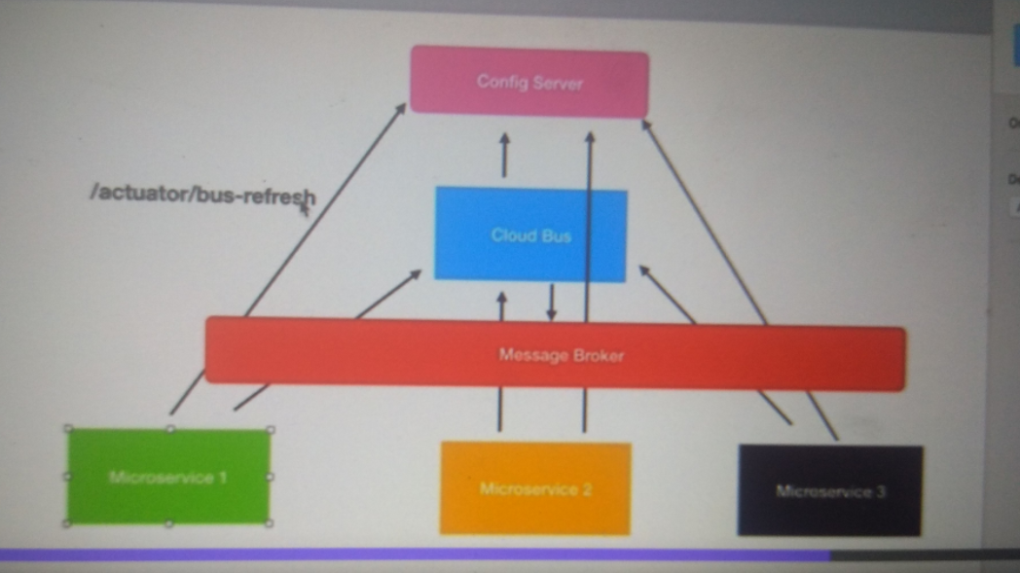

When we hit url



Cloud bus knows something has changed in configuration file. Cloud bus will let know all other instances of m/s

That configuration has got changed through this message broker it fires event and these m/s will automatically invoke config server to fetch the latest configuration that is concept of spring cloud bus

**Install rabbitMq**

<https://www.erlang.org/downloads>

<https://rabbitmq.com/install-windows.html>

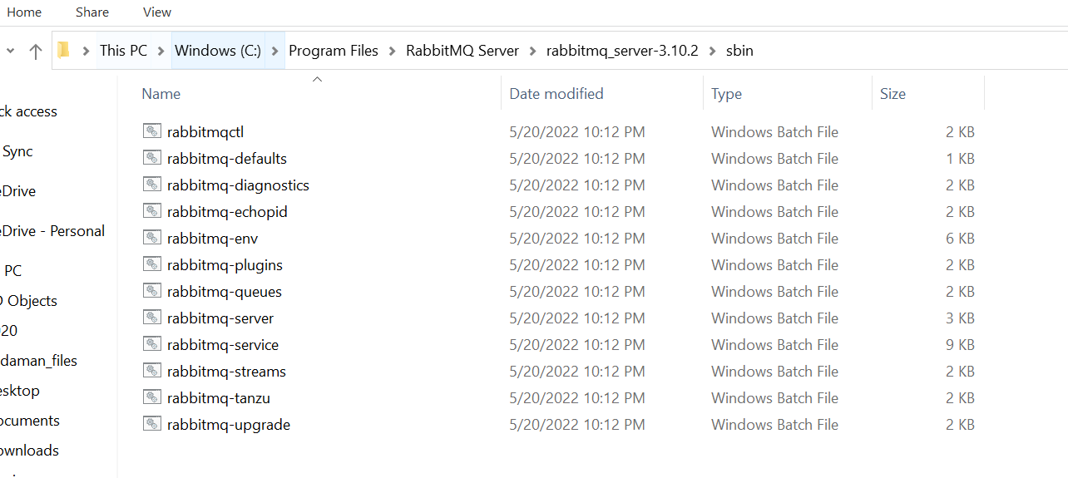

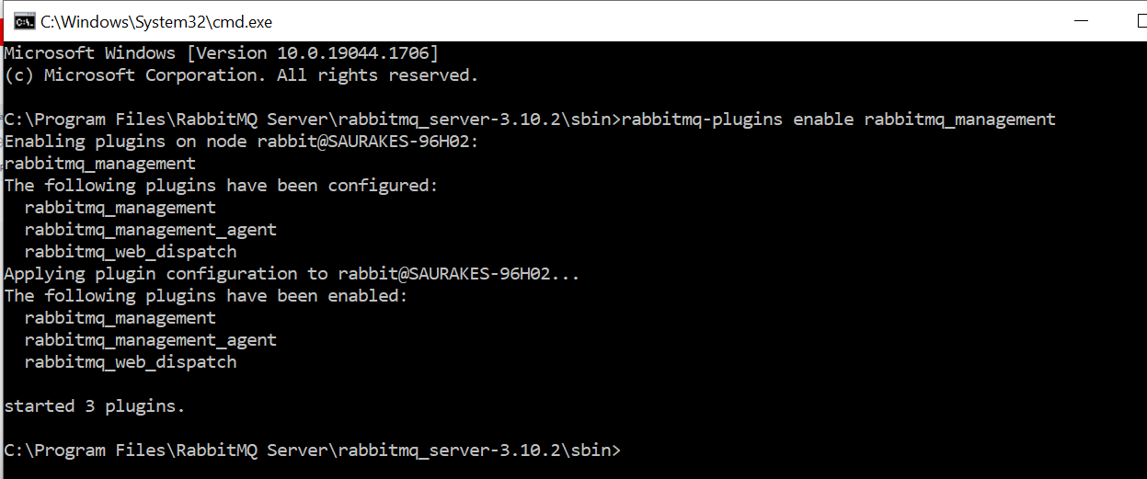

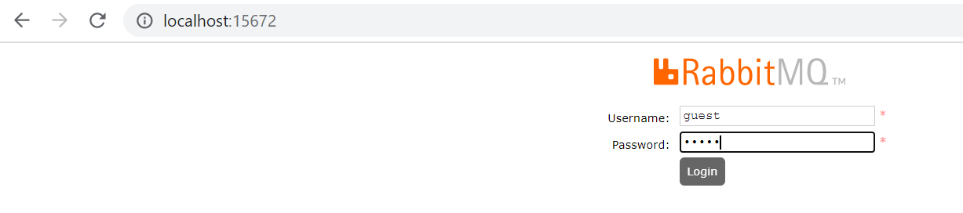

**Configure Cloud Bus**

**Will use spring cloud bus in ProductService ms**

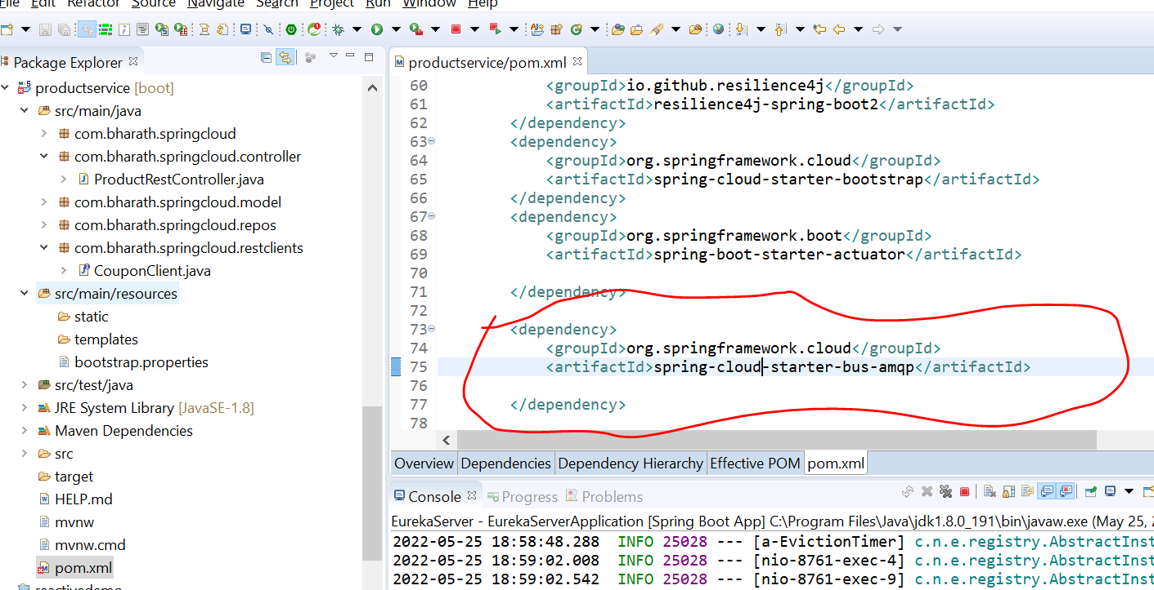

**This will be for rabbit mq and for kafka it will be bus-kafka**

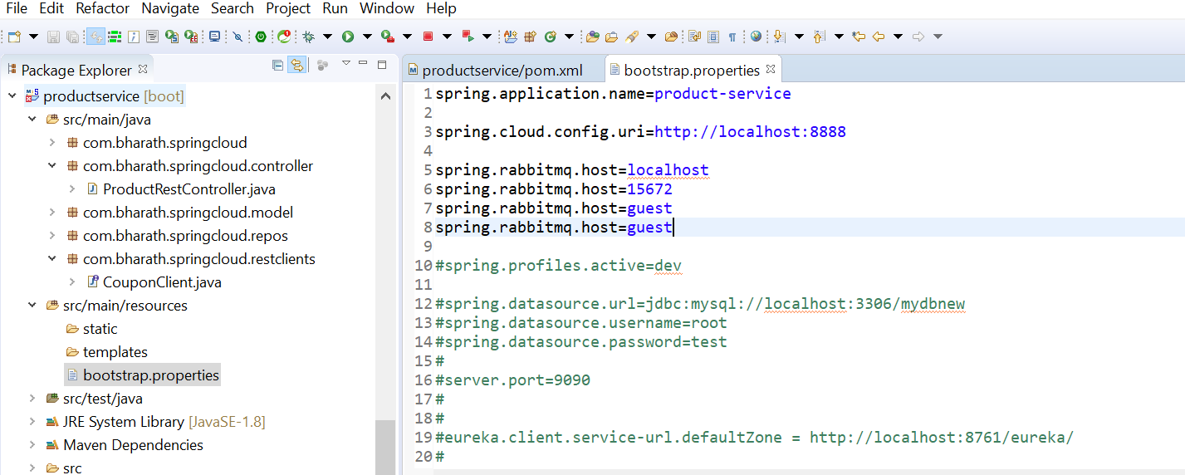

**Legacy Component Ribbon,Zuul, Hystrix**

**Client side load balancing :-** Ribbon

As the no of request to our m/s increasing we will be scaling our application across diff server that is will deploy same m/s and multiple instance of m/s running on diff server so that client can call one of the instances as required so instead of all client calling same service the load should be distributed across these multiple instance of m/s running. To do client side load balancing we use **ribbon from spring clould. Feign we already used that integrates with ribbon**

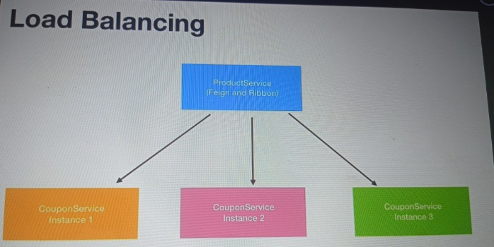

**Very imp :--- all are depreciated**

